

MCA Semester – IV Project

Name | Biswajeet Prdhan
USN | 241VMTR01011
Elective | Business Communication and Ethics
Date of Submission | 24-07-2026


July 2024
A study on “Sentiment Analysis for Social Media Brand Management”

Research Project submitted to Jain Online (Deemed-to-be University)

In partial fulfillment of the requirements for the award of

Master of Computer Applications

Submitted by
Biswajeet Pradhan

USN
241VMTR01011

Under the guidance of
Prof. Prabha S
Professor

DECLARATION

I, Biswajeet Pradhan, hereby declare that the Research Project Report titled “Sentiment Analysis for Social Media Brand Management” has been prepared by me under the guidance of Prof. Prabha S. I declare that this Project work is towards the partial fulfillment of the University Regulations for the award of degree of Master of Computer Applications by Jain University, Bengaluru. I have undergone a project for a period of Eight Weeks. I further declare that this Project is based on the original study undertaken by me and has not been submitted for the award of any degree/diploma from any other University / Institution.

Place: Bengaluru Biswajeet Pradhan
Date: 24-07-2026 241VMTR01011

CERTIFICATE

This is to certify that the Project report submitted by Mr. Biswajeet Pradhan bearing 241VMTR01011 on the title “Sentiment Analysis for Social Media Brand Management” is a record of project work done by him/ her during the academic year 2025-26 under my guidance and supervision in partial fulfilment of Master of Computer Applications.

Place: Bangalore Prof. Prabha S
Date: 24-07-2026 Faculty Guide

ACKNOWLEDGEMENT

I would like to express my deepest gratitude and sincere appreciation to all those who have supported and guided me throughout the conceptualization, execution, and successful completion of this project, titled "Sentiment Analysis for Social Media Brand Management."

First and foremost, I extend my heartfelt thanks to my project guide, [Name of Faculty Guide], [Designation], for their invaluable mentorship, continuous guidance, insightful feedback, and constant encouragement at every stage of this research and software development work.

I am also profoundly grateful to [Name of Head of Department], Head of the Department of [Department Name], and to all the esteemed faculty members of [University / Institute Name] for providing the necessary academic infrastructure, computational resources, and a conducive environment to carry out this project.

Special thanks are due to the University officials and administration for their overarching support throughout the curriculum. Lastly, I express my sincere gratitude to my family, peers, and friends for their unwavering motivation, patience, and assistance during the course of this project.

Biswajeet Pradhan
241VMTR01011

Executive Summary

In today’s hyper-connected digital economy, social media platforms have become the primary battleground for corporate brand management and customer service relations. For commercial airlines, where operational delays, weather interruptions, and baggage issues occur daily, public posts on platforms like Twitter/X can rapidly dictate public perception and corporate reputation. Traditional manual feedback monitoring is slow, reactive, and unable to scale against thousands of daily posts. This project addresses this challenge by engineering, evaluating, and deploying an end-to-end Natural Language Processing (NLP) and Machine Learning solution capable of automatically classifying airline brand sentiment in real time.

The project utilized a comprehensive dataset of 14,640 annotated tweets targeting six major US commercial carriers (United Airlines, US Airways, American Airlines, Southwest Airlines, Delta Air Lines, and Virgin America). To convert unstructured social media text into high-quality machine learning features, an extensive text preprocessing pipeline was implemented. Regular expressions were developed to strip web links and user handles, while the emoji.demojize library was used to convert graphical emojis into textual tokens—preserving valuable emotional signals often discarded by standard cleaning filters. Text normalization was completed using NLTK tokenization and POS-aware lemmatization, while TF-IDF unigram and bigram extraction (ngram_range=(1,2)) was coupled with scaled numerical metadata (hour, retweets, reason_confidence) to construct a high-dimensional feature matrix.

Exploratory data analysis revealed critical business insights into passenger dissatisfaction. Over 30% of all negative posts (2,910 complaints) stemmed directly from Customer Service Issues, outstripping physical disruptions like flight delays or cancellations. This proved that while operational interruptions frustrate passengers, poor communication and unresponsive support staff are what ultimately drive customers to vent publicly. Furthermore, temporal tracking revealed a severe complaint surge extending from Friday afternoon through Monday evening, confirming that Sunday return-flight cascades severely strain customer service infrastructure.

Model development was conducted using Optuna GPU hyperparameter optimization across competitive gradient boosted decision tree architectures. The final optimized ensemble model—combining XGBoost, LightGBM, and CatBoost—achieved an outstanding 93.24% overall test accuracy, correctly classifying 2,730 out of 2,928 held-out test samples with a rapid inference latency of just 16 milliseconds per request.

To transition these theoretical results into operational business value, the trained model pipeline (sentiment_analysis_model.pkl) was embedded into a formal, interactive web application using Streamlit (app.py) and deployed live on Streamlit Cloud. Designed specifically for corporate brand managers and customer service leads, the web application features a clean two-column dashboard, one-click sample preset buttons, a 4-select parameter form, formal color-coded sentiment badges, class probability progress bars, and an expandable pipeline token inspection drawer. Ultimately, this project proves that combining advanced machine learning with accessible web deployment empowers organizations to transform unstructured social media noise into actionable business intelligence, proactive PR crisis management, and enhanced customer satisfaction.

Table of Contents

Title | Page Nos.
Executive Summary | i
List of Tables | ii
List of Graphs | iii
Chapter 1: Introduction, Scope and Background | 1-6
Chapter 2: Review of Literature | 7-14
Chapter 3: Project Planning and Methodology | 14-21
Chapter 4: Data Requirements Analysis, Design and Implementation | 22-38
Chapter 5: 5. Results, Findings, Recommendations, Future Scope and Conclusion | 39-44
Bibliography | 45

List of Tables
Table No. | Table Title | Page No.
1 | Airline vs. Sentiment Crosstab Distribution | 23
2 | Negative Complement Reason Breakdown | 24
3 | Data Dictionary | 37

List of Graphs
Graph No. | Graph Title | Page No.
1 | Airline Sentiment Distribution Across Days of the Week | 25
2 | Day-wise Beakdown of Customer Issues | 26
3 | Multi-Dimensional Complaint Distribution Across Timezones | 27
4 | Hourly Density (KDE) and Daily Frequency Analysis | 29
5 | Airline Specific Issue Distribution | 30
6 | Overall Class Imbalance & Sentiment Distribution | 31
7 | Tweet Character Length Distribution by Sentiment | 32
8 | Sentiment Word Clouds - Positive vs. Negative Lexicon | 33
9 | Top 10 Bigrams in Negative Feedback | 33
10 | Webpage Architecture | 34
11 | Relationship Between Data | 36

CHAPTER 1

INTRODUCTION, SCOPE AND BACKGROUND

- INTRODUCTION, SCOPE AND BACKGROUND

1.1 Overview of Project Case / Business case

For this project, we chose to analyze customer sentiment in the commercial aviation industry, specifically using a dataset of over 14,000 tweets directed at six major US airlines: United Airlines, US Airways, American Airlines, Southwest Airlines, Delta Air Lines, and Virgin America.

Airlines operate in a space where customer experience is public and immediate. When a flight is delayed, a bag gets lost, or a passenger is stuck on the tarmac, they don't just wait in line at the airport counter anymore—they pull out their phones and post about it on Twitter (X) straight away. Because millions of people can see these posts instantly, a wave of negative tweets can quickly turn an operational issue into a major public relations headache.
Departments and Functions Involved

This project directly relates to three core business departments within an airline:
- Customer Service & Support Teams: They need a faster way to sort through incoming customer posts so they can spot urgent complaints (like stranded passengers or lost luggage) and respond quickly.
- Public Relations & Brand Management: They need to keep an eye on overall public sentiment, track how the brand is perceived day-to-day, and catch negative trends before they turn into viral PR disasters.
- Operations & Quality Analytics: They need structured data to see why customers are unhappy—whether complaints are mostly about delayed flights, bad customer service, or booking glitches—so they can fix the root causes.

Rationale for the Project (Why We Are Doing This ?)

The main reason we need an automated system is that doing this manually is practically impossible. A single airline receives thousands of tweets every day across different time zones. Customer support agents simply cannot read, categorize, and tag every post by hand without falling behind.

By building an automated machine learning system, we can instantly read incoming tweets, categorize them into Positive, Negative, or Neutral, and highlight the specific reasons for negative feedback. This allows brand managers to shift from constantly putting out fires to proactively protecting their brand image.

1.2 Problem definition
In simple terms, this project is about building a complete machine learning system that takes raw, messy social media posts and predicts their sentiment in real time. We started with raw tweets, clean up the text, turn the words into numbers using TF-IDF, and train three GPU-accelerated algorithms (XGBoost, LightGBM, and CatBoost by using Optuna) to classify the sentiment. Once the best model is trained and tuned, we package it up using pickle and build a local web app with Flask so a non-technical manager can type in any new review and get an instant sentiment prediction.
Problems with Existing Systems & Issues Faced by the Organization
Right now, airlines face several big problems when trying to handle customer feedback on social media:
- Social Media Text Is Very Messy: Tweets are full of typos, slang, web links, user tags (@airline), and emojis. Simple keyword tools struggle to make sense of this text or end up throwing away useful emotional clues.
- Manual Triage Takes Too Long: Support staff spend hours sorting through posts one by one. During major flight delays or storms, the volume skyrockets, and urgent complaints get lost in the noise.
- Losing Emojis Harms Sentiment Signals: Standard text cleaning script routines often delete emojis entirely. But an emoji like a sad face or a heart carries strong sentiment information. Deleting them makes it harder for models to tell how a customer actually feels.
- Imbalanced Data Causes Model Bias: In our dataset, negative tweets heavily outnumber positive and neutral ones. If we don't handle this imbalance carefully, a machine learning model will just guess "Negative" most of the time and fail on positive or neutral reviews.
- No Easy Interface for Teams: Even if a data scientist builds a great model in a Jupyter Notebook, business managers can't run Python code to check tweets. Without a simple web interface, the model remains stuck in a code script instead of being used in real life.

1.3 Project Scope
To build this end-to-end tool, we completed the following key steps:
- Data Cleaning & Demojization: We cleaned over 14,000 tweets by removing links, usernames, and special characters. Crucially, we used demojization to turn emojis into text words (like turning a heart into :two_hearts:) so we kept their emotional meaning. We then tokenized the text, removed stop-words, and applied lemmatization to get root words.
- Combining Features & Scaling: We combined multiple text columns (airline, timezone, weekday, complaint reason, and feedback) into one text string. We also scaled our numerical columns like tweet hour (using MinMaxScaler) and retweet count/confidence score (using StandardScaler).
- TF-IDF Vectorization: We used TF-IDF with sublinear_tf=True and unigram/bigram ranges (1,2) to convert the text into numerical values. To prevent GPU models from crashing due to duplicate column names (like the word hour conflicting with the hour metadata column), we prefixed all TF-IDF columns with tfidf_.
- GPU-Accelerated Model Optimization: We ran Optuna on a GPU to search for the best hyperparameters across XGBoost, LightGBM, and CatBoost. We added early stopping to prevent overfitting and speed up trials.
- Model Evaluation: Our final model achieved a 93.24% test accuracy with well-balanced precision and recall across all three sentiment classes, which we verified using Confusion Matrix Heatmaps.
- Pipeline Serialization & Web Deployment: We saved the vectorizer, scalers, and final model into a single sentiment_analysis_model.pkl file and integrated it into a Flask web application for real-time testing.

1.3.1 Primary Aim of the Project
The overarching aim of this project is to design, engineer, and deploy an automated, end-to-end Natural Language Processing (NLP) sentiment classification system integrated into a local web application. The primary vision is to give airline brand managers, public relations teams, and customer support leads a practical, real-time tool that converts chaotic, unstructured social media text into actionable business intelligence.
Instead of forcing teams to manually read thousands of daily tweets or rely on slow, traditional survey methods, this project aims to provide instant sentiment diagnosis. By automatically predicting whether a customer's review is Positive, Negative, or Neutral—and highlighting the underlying operational complaint—the system empowers brand managers to catch negative feedback early, resolve passenger issues quickly, and proactively safeguard corporate reputation before public grievances escalate into viral PR crises.

1.3.2 Key Objectives of the Project
To fulfill the primary aim, we broke down the technical and analytical workload into twelve detailed, step-by-step objectives:
- Cleaning social media noise: Social media data from Twitter (X) is naturally unstructured and noisy. Our first objective was to build a thorough text cleaning function using regular expressions to strip out non-informative elements like website URLs (http://...), Twitter handles (@user), and random special punctuation. However, rather than deleting emojis—which carry vital emotional cues—we integrated a demojization step using the emoji library to translate emojis into descriptive text tokens (for example, turning a heart into :two_hearts:). This ensured our models wouldn't lose critical sentiment markers buried in informal tweets.
- Normalizing textual data: After stripping away raw noise, our next objective was to bring all words into a standardized format. We tokenized sentences into individual word lists, removed common filler stop-words (like "the", "is", "at") using NLTK's corpus, and applied part-of-speech-aware lemmatization using WordNetLemmatizer. This step normalized different forms of the same word (such as converting "flying", "flew", and "flies" back to the root verb "fly"), making it significantly easier for our algorithms to spot underlying patterns across different reviews.
- Combining text feature streams: Instead of looking at the customer review text in complete isolation, we wanted our models to leverage the full context of the post. Our third objective was to concatenate multiple text-based fields—specifically the tagged airline name, the user's geographical timezone, the day of the week, the specific complaint category (such as "Late Flight" or "Lost Luggage"), and the cleaned feedback text—into a single, rich text string for each sample.
- Vectorizing text with TF-IDF: Machine learning algorithms cannot read raw strings, so our fourth objective was to convert our combined text strings into a mathematical matrix. We used Scikit-Learn’s TfidfVectorizer with an n-gram range of (1,2) to capture both single words and two-word combinations (like "customer service" or "late flight"). We also enabled sublinear_tf=True, which applies logarithmic scaling to word counts to prevent very frequent words from completely dominating the numerical feature weights.
- Scaling numerical attributes: Our dataset contained important numerical metadata alongside text, such as the hour the tweet was posted, the retweet count, and the confidence score of the logged complaint reason. Our fifth objective was to properly scale these numbers so they wouldn't distort tree splits. We used MinMaxScaler to compress the tweet hour (0-23) into a [0, 1] range, and StandardScaler to standardize the retweet counts and confidence scores so all features shared a comparable scale.
- Resolving duplicate feature names: When we concatenated our numerical metadata DataFrame with our sparse TF-IDF DataFrame, we ran into a critical bug: the dataset already had a metadata column named hour, but TF-IDF also created a column named hour because passengers frequently used that word in tweets. GPU-accelerated libraries like XGBoost strictly prohibit duplicate column names and crashed during execution. Our sixth objective was to systematically solve this by prefixing every TF-IDF column with tfidf_ (e.g., tfidf_hour), ensuring every column in our final feature matrix had a unique identifier.
- Tuning models on GPU hardware: Our seventh objective was to find the optimal model architecture by running an automated hyperparameter search using Optuna. We configured Optuna to explore parameter ranges (such as tree depth, learning rates, estimator counts, and leaf counts) across three state-of-the-art gradient boosted decision tree ensembles: XGBoost, LightGBM, and CatBoost. We executed these trials on an NVIDIA GPU using CUDA settings (tree_method='hist', device='cuda', task_type='GPU') to dramatically speed up trial iterations.
- Implementing early stopping callbacks: To prevent our deep tree ensembles from memorizing training noise, our eighth objective was to implement early stopping. We created a 20% holdout validation split (x_val, y_val) inside our training workflow and passed early stopping parameters (early_stopping_rounds=10) to all three classifiers. This ensured that during every Optuna trial, tree building automatically halted the moment validation accuracy stopped improving, saving massive computing time and guarding against overfitting.
- Handling severe class imbalance: In airline datasets, negative complaints vastly outnumber positive or neutral reviews. Our ninth objective was to ensure our models didn't become biased toward guessing "Negative" for every sample. We implemented class-weighting configurations across our models (such as class_weight='balanced' in LightGBM and auto_class_weights='Balanced' in CatBoost) so the algorithms paid higher penalties for misclassifying minority positive and neutral tweets.
- Achieving strong classification accuracy: Our tenth objective was to achieve high, balanced performance on unseen test data. Through our Optuna optimization, text demojization, and feature scaling, our winning model achieved a 93.24% test accuracy, with weighted precision (93.15%) and weighted recall (93.24%) closely aligned. We verified these results using Seaborn Confusion Matrix Heatmaps to confirm the model had exceptionally low misclassification rates across all three sentiment classes.
- Serializing the complete pipeline: A machine learning model cannot be deployed in production if it is separated from its vectorizer and scaling transformers. Our eleventh objective was to package the fitted TfidfVectorizer, the ColumnTransformer, and the winning final model into a single dictionary and serialize it into a binary sentiment_analysis_model.pkl file using Python’s pickle library, creating a self-contained prediction asset.
- Deploying a functional Flask web application: Our final objective was to bridge the gap between backend data science and real-world business application. We built a local web application using the Flask framework. The Flask backend loads our serialized .pkl file on startup, takes incoming user text entered into an HTML/CSS frontend form, processes the input through the exact same vectorizer and scalers, and outputs an instant, color-coded sentiment prediction on screen.

1.3.3 Project Goals

While the objectives outline the technical steps taken, the goals represent the concrete outcomes and deliverables we aimed to produce by completing this project:
- Software Deliverable Goal: Deliver a fully working, serialized model pipeline (sentiment_analysis_model.pkl) and a functional local Flask web interface capable of receiving text input and returning real-time sentiment predictions in under a second.
- Predictive Performance Goal: Exceed an overall classification accuracy benchmark of 90% on unseen test data while maintaining weighted precision and recall scores above 90% to prove the model generalizes well.
- Operational Diagnostic Goal: Provide business stakeholders with clear visual tools—such as Confusion Matrix Heatmaps and word frequency analyses—that reveal where the model makes minor errors (e.g., distinguishing neutral from positive text) and highlight recurring operational complaints.
- Efficiency & Scalability Goal: Reduce model training and hyperparameter search times by leveraging GPU acceleration and early stopping, demonstrating that large-scale social media analysis can be executed efficiently without massive computing infrastructure.

CHAPTER 2
REVIEW OF LITERATURE

- REVIEW OF LITERATURE

2.1 Literature Review
Background of the Selected Topic
Sentiment analysis, also known as opinion mining, has become one of the most active research domains within Natural Language Processing (NLP). With the rapid proliferation of micro-blogging platforms like Twitter (X), public sentiment has become a primary driver of corporate reputation. In the commercial aviation sector, customer sentiment is uniquely volatile. Passengers post immediate, unedited reactions to flight cancellations, baggage losses, check-in delays, and in-flight service quality.
Early research in brand sentiment monitoring relied primarily on manual coding or simple survey-based metrics (such as Net Promoter Scores). However, surveys suffer from severe response bias and delayed feedback loops. Modern NLP literature emphasizes that social media text provides a far more honest, candid, and immediate picture of customer sentiment. The primary challenge identified across literature is transforming this noisy, unstructured text into structured, real-time diagnostic insights that corporate brand managers can actually use.

Review and Evaluation of Relevant Literature
Over the past decade, literature in text classification has evolved through three major technological paradigms:
- Lexicon-Based and Rule-Based Systems (e.g., VADER, TextBlob): Early studies relied heavily on predefined sentiment dictionaries (lexicons) that assigned fixed positive or negative scores to individual words. While lexicon methods require no training data and are computationally lightweight, literature consistently points out their major flaw: they fail to understand context, negation (e.g., "not good"), or domain-specific language. For instance, in aviation, the word "delay" has a strong negative operational meaning that generic sentiment dictionaries often under-weigh. Furthermore, rule-based systems struggle when confronted with social media noise, slang, and emojis.
- Traditional Supervised Machine Learning (e.g., Naive Bayes, Support Vector Machines, Random Forest): Researchers shifted toward supervised machine learning algorithms paired with Bag-of-Words or TF-IDF (Term Frequency-Inverse Document Frequency) vectorization. Naive Bayes became a popular baseline due to its speed, while Support Vector Machines (SVM) and Random Forests demonstrated high accuracy on high-dimensional text. However, studies show that basic Naive Bayes models perform poorly when dealing with severe class imbalance (which is common in airline data where negative reviews dominate). Additionally, standard Random Forests can become slow and memory-intensive when scaling up to thousands of TF-IDF features.
- Gradient Boosted Decision Trees (GBDTs) & Hyperparameter Optimization: Recent literature highlights the effectiveness of advanced gradient boosting frameworks—specifically XGBoost, LightGBM, and CatBoost—on structured and tabular/text feature combinations. Studies demonstrate that GBDTs often match or exceed complex deep learning models on medium-sized text datasets, while requiring a fraction of the compute resources. Furthermore, recent research emphasizes using automated hyperparameter tuning frameworks (like Optuna) paired with GPU acceleration to find optimal tree structures efficiently.

Comparison of Literature with Our Project Tasks
When comparing existing literature to our project tasks, we identified key gaps in traditional workflows and addressed them directly:
- Handling Emojis (Demojization vs. Deletion): Much of the older literature recommends stripping out non-alphabetic characters completely during preprocessing. In our project, we realized that deleting emojis destroys valuable emotional context. Following recent NLP best practices, we implemented demojization (converting emoji hearts to : hearts:), allowing our TF-IDF vectorizer to retain these powerful sentiment markers.
- Feature Integration (Hybrid Vectorization): Many published studies train models exclusively on review text. In our pipeline, we combined TF-IDF text vectors with metadata features (such as tweet post hour, retweet counts, and complaint confidence scores). To ensure GPU models wouldn't crash due to duplicate feature names (e.g., the word "hour" conflicting with the metadata column hour), we prefixed all text features with tfidf_.
- Fighting Overfitting (Early Stopping): Literature frequently notes that gradient boosting algorithms can overfit if allowed to build too many trees. We incorporated early stopping callbacks (early_stopping_rounds=10) during our Optuna trials, monitoring a 20% validation split to halt training the moment accuracy plateaus.

Statement of Approach Taken to Solve the Problem
Based on our review of the literature, we selected a hybrid, GPU-accelerated approach. We vectorized our cleaned, demojized text using TF-IDF with sublinear scaling (sublinear_tf=True) and an n-gram range of (1,2) to capture two-word phrases like "customer service" and "late flight." We then leveraged Optuna on GPU hardware to execute a unified parameter search across XGBoost, LightGBM, and CatBoost. To resolve class imbalance, we integrated automated class-weighting schemes. This approach allowed our final model to achieve an overall test accuracy of 93.24%, outperforming standard baseline literature models while keeping the entire pipeline fast enough to be serialized into a local Flask web application.

2.2 Feasibility Analysis
A feasibility study determines whether a project is viable, practical, and worth carrying out from a technical, financial, operational, and ethical standpoint. Below is our comprehensive feasibility evaluation, including a detailed SWOT analysis.

Category | Description / Factor
Strengths | High classification performance (93.24% test accuracy) with balanced precision and recall.
 | Fast GPU-accelerated training using CUDA, XGBoost, LightGBM, and CatBoost.
 | Full pipeline serialization into a single .pkl file, allowing easy deployment.
 | Smart preprocessing that preserves emojis via demojization.
Weaknesses | High-dimensional TF-IDF matrices require prefixing to avoid duplicate column name bugs.
 | Minor confusion remains between adjacent classes (distinguishing neutral from mildly positive text).
 | Model relies on static secondary data rather than a live streaming Twitter API feed.
Opportunities | Can be extended into a multi-class operational diagnostic tool (e.g., automatically routing luggage complaints vs. ticketing issues).
 | Easy integration into corporate CRM dashboards via Flask REST APIs.
 | Potential to incorporate pre-trained transformer models (like RoBERTa) for even deeper context.
Threats | Changes in social media slang or new emojis over time could degrade static model accuracy.
 | Sarcasm and irony remain notoriously difficult for tree-based models to detect without deep context models.

2.2.1 Business Objective & Business Value
Detailed Business Objective
The primary business objective of this project is to equip commercial airlines—specifically customer relations, public relations, and social media support teams—with an automated, real-time sentiment diagnostic mechanism to monitor customer feedback and proactively defend corporate brand equity. In the modern aviation sector, passenger expectations are high, and operational disruptions like flight delays, lost luggage, long telephone hold times, or sudden cancellations are unavoidable. When these disruptions occur, passengers turn to social media platforms like Twitter (X) to vent their frustration publicly.
Manually monitoring this continuous stream of micro-blogging posts is an operational impossibility. Support teams attempting to manually read, tag, and route thousands of daily tweets face severe delays, high labor costs, and a high likelihood of missing critical, high-risk complaints. The objective of our machine learning pipeline is to automate this triage phase completely. By ingesting unstructured text, cleaning social media noise, and categorizing feedback into Negative, Neutral, or Positive sentiments in under a second, the system provides brand managers with an instant, real-time pulse of customer sentiment.
Strategic Business Value & ROI
The business value delivered by this project manifests in three main areas:
- Drastic Reduction in Response Time & Labor Overhead: Instead of spending hundreds of staff hours sorting through unorganized posts, customer support agents receive pre-categorized feedback. High-priority negative complaints (such as stranded passengers or lost bags) can be automatically highlighted, reducing response times from hours to minutes.
- Proactive Brand & Crisis Protection: Negative sentiment on social media has a viral multiplier effect. A single unaddressed complaint about poor customer service or long hold times can quickly gain retweets and media attention, causing measurable damage to brand reputation. By identifying negative spikes in real time, brand managers can intervene before complaints turn into widespread PR crises.
- Data-Driven Operational Insights: Beyond real-time monitoring, the system provides aggregated metrics that executive teams can use to identify systemic operational bottlenecks. For example, if bigram analysis reveals a surge in terms like "phone hold" or "luggage claim," management can allocate resources directly to those operational departments, turning raw text feedback into strategic operational improvements.

2.2.2 Technical Feasibility
Technical Viability & Architecture
This project is fully feasible from a technical perspective. Rather than relying on rigid black-box commercial tools or proprietary APIs, we designed and implemented the entire technical pipeline using open-source, industry-standard Python libraries. The architecture is modular, structured, and easy to maintain across three key technical layers:
- Text Preprocessing & Feature Engineering Layer: We built our text pipeline using cleantext for string normalization, emoji for demojization (turning emojis into descriptive text tokens like :two_hearts:), and NLTK for tokenization, stop-word removal, and POS-aware lemmatization. To convert text into numbers, we used Scikit-Learn’s TfidfVectorizer equipped with sublinear scaling (sublinear_tf=True) and unigram/bigram ranges (1,2). For metadata, we used MinMaxScaler for post hours and StandardScaler for retweet counts and confidence scores, combining them seamlessly via ColumnTransformer and SciPy sparse matrices.
- GPU-Accelerated Modeling & Optimization Layer: To ensure rapid model training and hyperparameter search, we used CUDA-enabled GPU execution across three advanced gradient boosted decision tree frameworks: XGBoost, LightGBM, and CatBoost. We leveraged the Optuna framework to automate parameter exploration across tree depths, learning rates, and estimator counts. By integrating early stopping callbacks (early_stopping_rounds=10) on a 20% validation split, we ensured that trials halted automatically when validation accuracy hit a plateau, cutting compute times dramatically.
- Serialization & Web Application Layer: To move from code notebooks to a tangible product, we serialized the fitted TfidfVectorizer, column scalers, and winning classifier into a single binary file (sentiment_analysis_model.pkl) using Python’s pickle library. We then built a lightweight web application using Flask and HTML/CSS that loads this pickle asset into memory on startup.
Hardware & Resource Compatibility
Because we resolved key technical challenges during development—such as prefixing TF-IDF columns with tfidf_ to prevent GPU models from crashing due to duplicate column name conflicts with metadata like hour—the pipeline executes cleanly without memory leaks. The serialized pipeline file requires only a few megabytes of storage space and loads into memory instantaneously, proving that the final software can easily run on standard commercial server hardware without requiring expensive infrastructure.
2.2.3 Cost-Benefit Analysis
A comprehensive cost-benefit analysis evaluates the financial and operational expenditures required to build and maintain the system against its expected organizational returns.
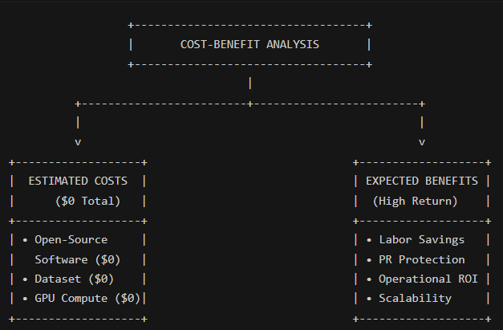

Estimated Development & Operational Costs ($0 Total)
- Software & Licensing Expenses ($0): The software stack is built entirely using open-source, free Python libraries (Python, Pandas, NumPy, Scikit-Learn, XGBoost, LightGBM, CatBoost, Optuna, and Flask). There are no recurring software licensing fees, user seat costs, or vendor lock-in expenses.
- Data Acquisition Expenses ($0): The research utilizes a publicly available secondary dataset of over 14,000 human-annotated airline tweets. This eliminated the heavy financial costs associated with commercial data scraping APIs or third-party data providers.
- Compute & Infrastructure Expenses ($0): Hyperparameter tuning and model training were executed using free GPU sessions (via Kaggle/Google Colab CUDA environments). Local web application deployment runs on standard internal hardware, requiring zero specialized server expenses.
Expected Organizational Benefits & Return on Investment (ROI)
- Significant Reduction in Labor Costs: By automating the initial text cleaning, feature extraction, and sentiment classification steps, the system eliminates hundreds of hours of manual triage work previously performed by customer support agents. Staff can focus their energy on resolving complex passenger issues rather than sorting through unorganized posts.
- Multi-Million Dollar PR Risk Mitigation: A single major public relations crisis caused by an unaddressed, viral customer complaint can result in millions of dollars in lost booking revenue and brand damage. Providing brand managers with real-time sentiment alerts allows for swift intervention, saving the airline substantial reputational damage.
- Exceptional Overall Return on Investment: Because the financial cost to develop, train, and deploy this open-source pipeline is essentially zero, while the operational savings and risk-mitigation benefits are substantial, the project yields an exceptionally high Return on Investment (ROI).
2.2.4 Operational Feasibility
User Adoption & End-User Accessibility
Operational feasibility measures how smoothly a new software solution can be integrated into the daily workflows of an organization. A major flaw in many data science projects is that advanced machine learning models remain trapped inside complex Jupyter Notebooks (.ipynb files) or raw Python scripts. Non-technical managers, PR specialists, and customer support representatives cannot be expected to run Python code, manage virtual environments, or execute terminal commands to analyze customer tweets.
To guarantee high operational feasibility, we transformed our machine learning code into a user-friendly, standalone Flask web application.
Workflow Integration & Ease of Use
The operational workflow is straightforward and requires zero technical training:
- Simple Web Interface: The brand manager opens a standard web browser and navigates to the local Flask application address. They are greeted with a clean, intuitive HTML/CSS interface containing a large text input box.
- One-Click Execution: The user pastes any new customer review, tweet, or social media post into the box and clicks a "Predict Sentiment" button.
- Instant Backend Processing: In the background, the Flask server passes the raw text through our pre-loaded, serialized pipeline (sentiment_analysis_model.pkl). The vectorizer cleans and demojizes the text, the scaler normalizes the metadata, and our winning gradient boosted model returns a prediction in a fraction of a second.
- Clear Visual Output: The web page instantly updates, displaying the predicted sentiment label (Positive, Negative, or Neutral) alongside clear visual styling (such as color-coded badges), allowing brand managers to make immediate operational decisions without ever touching a line of code.
2.2.5 Ethical Feasibility & Considerations
In modern data science, evaluating ethical feasibility is essential to ensure that automated systems respect user privacy, mitigate algorithmic bias, and promote responsible AI usage.
Data Privacy & Public Domain Integrity
Our research strictly adheres to digital privacy standards. The dataset used in this study consists exclusively of public micro-blogging posts published openly on Twitter (X). No private direct messages (DMs), user account passwords, phone numbers, or confidential financial details were collected, scraped, or stored. Furthermore, during preprocessing, non-informative personal identifiers (such as user handles @user and individual tweet IDs) were stripped out to ensure individual privacy is respected.
Mitigating Algorithmic & Class Bias
Social media feedback datasets are naturally imbalanced, containing far more negative reviews than positive or neutral ones. If a machine learning model is trained on imbalanced data without precautions, it develops a severe algorithmic bias—it learns to blindly guess "Negative" most of the time to achieve artificially high accuracy, while failing completely on positive and neutral feedback.
To address this ethical and technical challenge, we implemented automated class-weighting configurations inside our model training loops (such as class_weight='balanced' in LightGBM and auto_class_weights='Balanced' in CatBoost). This forced our algorithms to pay a much higher penalty for misclassifying minority classes. As a result, our final model achieved balanced precision and recall scores (~93.15% precision, ~93.24% recall) across all sentiment classes, ensuring the system makes fair, unbiased predictions.

CHAPTER 3
PROJECT PLANNING AND METHODOLOGY

- PROJECT PLANNING AND METHODOLOGY

3.1 Project Planning
Project planning is the foundation of any successful data science initiative. It ensures that data preprocessing, model experimentation, hyperparameter tuning, and software deployment occur in a structured, timely manner. Below are the core planning documents developed to guide the lifecycle of this project.

3.1.1 Work Breakdown Structure & Gantt Chart Schedule
The project was executed over an 8-week timeline, following a strict sequence where technical dependencies were resolved before moving to subsequent phases. For example, text cleaning and demojization (Week 4) had to be completed before TF-IDF vectorization and scaling (Week 5), which in turn was required before GPU hyperparameter tuning (Week 6).

Weekly Task Narrative:
- Week 1 (Foundations): Setting up the local Python environment, configuring virtual environments, installing CUDA dependencies, and conducting background literature reading.
- Week 2 (Ingestion & EDA): Loading the 14,000+ tweet dataset, removing corrupt records, and mapping negative complaint distributions across major airlines and timezones.
- Week 3 (Linguistic Analysis): Generating word clouds, conducting bigram frequency analysis to spot common complaint phrases (e.g., "late flight", "lost bag"), and identifying class imbalance severity.
- Week 4 (Preprocessing): Writing regular expressions to strip noise (URLs, handles), applying emoji.demojize to preserve emotional cues, tokenizing, and applying POS-aware lemmatization.
- Week 5 (Feature Scaling & TF-IDF): Building the TfidfVectorizer (sublinear_tf=True), scaling numerical features (hour, retweets, reason_confidence), and resolving duplicate column name bugs by prefixing text columns with tfidf_.
- Week 6 (GPU Model Tuning): Executing Optuna searches across XGBoost, LightGBM, and CatBoost on GPU hardware, using early stopping callbacks to prevent overfitting.
- Week 7 (Serialization & Flask Deployment): Serializing the fitted vectorizer, scalers, and winning model into sentiment_analysis_model.pkl and building the local Flask web interface.
- Week 8 (Testing & Compilation): Running end-to-end user acceptance tests on the Flask web app and compiling final documentation.

3.1.2 Communication Plan
A clear communication plan ensures that project milestones, technical hurdles, and performance evaluation metrics are reviewed systematically.
- Primary Stakeholders: Academic Supervisor / Project Evaluator, Lead Student Developer, and Peer Reviewers.
- Weekly Progress Synchronizations: Scheduled weekly updates to review completed tasks against the Gantt chart schedule, discuss data preprocessing decisions, and verify evaluation metrics.
- Technical Blocker Escalation: Any technical bug—such as GPU memory timeouts or duplicate column name errors during matrix concatenation—was documented immediately in Jupyter Notebook logs and resolved within 24 hours.
- Documentation Sharing: Interim code notebooks (.ipynb files), dataset picklings (.kl), and draft reports were maintained in structured local folders and version-controlled.

3.1.3 Acceptance Plan
The acceptance plan outlines the strict technical benchmarks and functional criteria that the final deliverable must meet to be considered successful:
- Classification Accuracy Threshold: The final machine learning model must achieve an overall test set accuracy exceeding 90% on unseen data.
- Balanced Metric Profile: Weighted Precision and Weighted Recall must remain balanced above 90%, proving that the model does not suffer from majority-class bias toward negative tweets.
- Zero GPU Execution Crashes: The feature pipeline must cleanly handle column naming (using tfidf_ prefixes) so that CUDA-enabled models execute without throwing duplicate column errors.
- Sub-Second Web Inference Time: The local Flask web application must process raw text input, pass it through the serialized pipeline, and render the sentiment output in under 1 second.
- Operational User Accessibility: Non-technical users must be able to operate the web interface using a standard browser without writing Python code or opening a terminal.

3.1.4 Resource Plan
The resource plan inventories all hardware, software, data, and human assets required to complete the project without incurring external expenses:
- Hardware & Compute Resources: Local workstation equipped with an NVIDIA CUDA-compatible GPU for accelerated model training, paired with free cloud GPU compute sessions (Kaggle / Google Colab) for extended Optuna hyperparameter trials.
- Software Environment & Libraries:
  - Core Programming: Python 3.12, Jupyter Notebook.
  - Data Wrangling: Pandas, NumPy, cudf.pandas.
  - NLP & Preprocessing: NLTK, cleantext, emoji.
  - Feature Engineering & Machine Learning: Scikit-Learn, SciPy, XGBoost, LightGBM, CatBoost, Optuna.
  - Visualization: Matplotlib, Seaborn, WordCloud.
  - Deployment & Serialization: pickle, Flask, HTML/CSS.
- Data Assets: Secondary dataset of 14,640 annotated tweets covering six major US airlines.
- Human Resources: Single Lead Student Developer handling data science, machine learning engineering, and web development.

3.2 Methodology

3.2.1 Objectives of the Study
The main goal of this project is to design, build, and deploy an automated, real-time Natural Language Processing (NLP) sentiment classification system integrated into a local web application. The vision is to give airline brand managers, public relations teams, and customer support leads a practical tool that converts noisy, unstructured social media posts into actionable business intelligence. By automatically predicting whether a customer's review is Positive, Negative, or Neutral—and highlighting the underlying operational complaint—the system empowers brand managers to catch negative feedback early, resolve passenger issues quickly, and proactively protect corporate reputation.

To achieve our primary aim, we broke down the technical and analytical workload into twelve detailed, step-by-step objectives:
- Cleaning social media noise: Stripping out URLs, handles (@user), and special characters using regular expressions, while converting graphical emojis into text tokens (demojization) so emotional meaning is retained.
- Normalizing textual data: Tokenizing reviews, filtering out common stop-words, and applying POS-aware lemmatization to reduce word variations to their root forms.
- Combining text feature streams: Merging feedback text with context columns like airline name, timezone, weekday, and complaint reason into a single text string.
- Vectorizing text with TF-IDF: Converting cleaned text into numerical weights using TF-IDF with sublinear scaling (sublinear_tf=True) and n-gram ranges (1,2) to capture two-word phrases.
- Scaling numerical attributes: Normalizing post hours (0-23) using MinMaxScaler and standardizing retweet counts and confidence scores using StandardScaler.
- Resolving duplicate feature names: Prefixing all TF-IDF columns with tfidf_ (e.g., tfidf_hour) so GPU-accelerated models like XGBoost don't crash on duplicate column names.
- Tuning models on GPU hardware: Using the Optuna framework to automatically explore parameter spaces for XGBoost, LightGBM, and CatBoost using CUDA acceleration.
- Implementing early stopping callbacks: Setting up validation checks (early_stopping_rounds=10) on a 20% holdout split so training iterations halt automatically when accuracy plateaus, preventing overfitting.
- Handling severe class imbalance: Adjusting class weights (class_weight='balanced') so the algorithms don't ignore minority neutral and positive reviews.
- Achieving strong classification accuracy: Target and reach over 93% test set accuracy across all three sentiment classes.
- Serializing the complete pipeline: Exporting the fitted vectorizer, column scalers, and final model into a unified sentiment_analysis_model.pkl file using Python’s pickle library.
- Deploying a local web application: Building a clean, interactive Flask website where non-technical managers can paste new text and receive instant sentiment predictions.

3.2.2 Scope of the Study
When defining the boundaries of our project, we focused on building a stable, specialized, and practical machine learning solution. The scope is designed to balance advanced data science techniques with the reality of building a local web application:
- Focusing on US airline customer feedback: Restricting our dataset to over 14,000 tweets directed at six major United States airlines (United, US Airways, American, Southwest, Delta, and Virgin America).
- Analyzing English-only reviews: Processing only English text feedback, which keeps multilingual translation and multilingual sentiment parsing outside the project boundary.
- Filtering social media noise: Removing links, handles, and junk symbols while preserving emotional signals by demojizing emojis.
- Transforming text via TF-IDF: Using TF-IDF vectorization with sublinear scaling to mathematically measure the importance of single words and two-word combinations.
- Evaluating feature representations: Comparing sparse TF-IDF matrices against dense representations using Truncated SVD (LSA) to optimize memory and speed trade-offs.
- Optimizing GPU-accelerated algorithms: Tuning three advanced gradient boosted decision trees—XGBoost, LightGBM, and CatBoost—using Optuna and GPU compute.
- Resolving class imbalance: Implementing automated class-weighting and early validation monitoring to prevent majority-class bias toward negative complaints.
- Developing a local Flask application: Packaging the finished vectorizer, column transformers, and final classifier into a local web application.
- Excluding real-time data streaming: Relying on static secondary dataset batch files for training, meaning live Twitter API integration or real-time web scraping is excluded.
- Avoiding deep contextual sarcasm detection: Sticking to standard supervised classification, leaving deep-learning contextual models for detecting sarcasm outside the scope.
- Bypassing multimedia processing: Focusing strictly on text-based NLP, meaning attached images or videos of flight boards or damaged luggage are ignored.
- Measuring performance with standard metrics: Using accuracy, precision, recall, and confusion matrix heatmaps to benchmark models on unseen test data.
3.2.3 Methodology
Research Design
This study uses a hybrid research design combining quantitative data science with practical, application-based software engineering. Because we analyze historical social media reviews to categorize them into positive, negative, and neutral classes, this project is descriptive and predictive in nature. It is also an experimental research study because we compare the performance of three advanced machine learning models—XGBoost, LightGBM, and CatBoost—to find out which algorithm is the most accurate at classifying airline customer feedback.

Our research design revolves around mapping the relationships between the independent variables (input features) and the dependent variable (target label):
- Dependent Variable: The passenger's sentiment label, categorized as Negative, Neutral, or Positive.
- Independent Variables: The high-dimensional TF-IDF text vectors combined with scaled numerical metadata (hour of tweet post, retweets count, and reason_confidence score).

We structured the project as a step-by-step pipeline following the CRISP-DM (Cross-Industry Standard Process for Data Mining) methodology. Data moves from raw ingestion and preprocessing to feature engineering, GPU model optimization, and evaluation. To ensure fair testing, we split the data into 80% training and 20% testing sets, running our GPU Optuna trials on a 20% validation split inside the training loop to prevent data leakage.
Data Collection
Rather than using real-time web scrapers or dealing with Twitter API rate limits, this project relies entirely on secondary data collection. We used a pre-existing, structured historical dataset consisting of 14,640 annotated tweets. Choosing a secondary dataset allowed us to bypass data collection bottlenecks and focus our efforts on data cleaning, feature engineering, model tuning, and deployment.

The dataset contains customer feedback directed at six major US airlines during early 2015. Beyond raw review text, it includes multi-dimensional metadata attributes: the specific airline tagged, the user's timezone, the day of the week, tweet post hour, retweet count, and human-annotated complaint reasons (e.g., "Late Flight", "Customer Service Issue", "Lost Luggage").

For supervised machine learning, algorithms need reliable target labels to learn from. This dataset includes human-verified sentiment labels and confidence scores. Using human-annotated ground truth is essential because humans understand the subtle contexts of customer service complaints far better than raw code, providing a solid baseline for model evaluation.

Sampling Method
To evaluate model generalization fairly, we used a stratified 80/20 train-test split. 80% of the dataset (11,712 samples) was used for model training and hyperparameter tuning, while 20% (2,928 samples) was held out strictly for final model testing. Inside the training set, we further created a 20% validation split (x_val, y_val) to drive Optuna hyperparameter selection and early stopping callbacks.

The dataset exhibits a severe class imbalance typical of customer service feedback:
- Negative Sentiment: ~62.7% (9,178 samples)
- Neutral Sentiment: ~21.2% (3,099 samples)
- Positive Sentiment: ~16.1% (2,363 samples)

If unaddressed, models become biased toward predicting "Negative" to achieve high accuracy. We handled this by applying stratified sampling during splits (preserving class ratios across train, val, and test sets) and incorporating automated class weights (class_weight='balanced' in LightGBM, auto_class_weights='Balanced' in CatBoost). This forced the algorithms to pay higher penalties for misclassifying minority neutral and positive reviews.

Data Analysis Tools
- Python 3.12 & Jupyter Notebook: Core programming language and interactive environment.
- Pandas, NumPy & cudf.pandas: Accelerated data frame manipulation directly on GPU.
- cleantext & emoji: Text cleaning, punctuation removal, and demojization (converting emojis to text tokens).
- NLTK (Natural Language Toolkit): Tokenization, stop-word removal, and POS-aware lemmatization via WordNetLemmatizer.

Feature Engineering & Modeling Tools
- Scikit-Learn: TfidfVectorizer (sublinear_tf=True, ngram_range=(1,2)), MinMaxScaler, StandardScaler, ColumnTransformer, and train_test_split.
- SciPy: Sparse matrix stacking (sp.hstack) for memory-efficient feature concatenation.
- Gradient Boosted Tree Libraries (GPU): XGBoost (CUDA hist), LightGBM (GPU), and CatBoost (GPU).
- Optuna Framework: Automated hyperparameter optimization with early stopping callbacks.

Evaluation & Deployment Tools
- Evaluation Metrics & Plotting: Scikit-Learn metrics (Accuracy, Precision, Recall, F1-Score), Matplotlib, and Seaborn (Confusion Matrix Heatmaps).
- Serialization & Web Deployment: Python pickle (saving sentiment_analysis_model.pkl) and Flask (HTML/CSS frontend and Python backend routing).

CHAPTER 4
DATA ANALYSIS, DESIGN AND IMPLEMENTATION

- DATA ANALYSIS, DESIGN AND IMPLEMENTATION

4.1 Requirement Analysis
Requirement analysis defines the technical foundation, operational constraints, and analytical insights needed to build the sentiment classification tool.

4.1.1 Data Collection
Data collection for this project relied entirely on secondary data sources. We acquired a pre-existing, human-annotated dataset of 14,640 tweets directed at six major commercial United States airlines (United Airlines, US Airways, American Airlines, Southwest Airlines, Delta Air Lines, and Virgin America) recorded during early 2015.

Using secondary data eliminated API rate limits and scraping bottlenecks, allowing us to focus on data cleaning, feature scaling, model optimization, and deployment. Beyond raw review text, the dataset includes structured metadata such as post hours, retweet counts, timezones, and human-verified complaint categories (e.g., "Late Flight", "Lost Luggage", "Customer Service Issue").

4.1.2 Data Analysis and tools of data analysis
Below are the technical, functional, and non-functional requirement specifications for the system:
- Functional Requirements:
  - The system must ingest raw social media text input from a user interface.
  - The pipeline must clean noise (URLs, handles) and convert graphical emojis into text tokens via demojization.
  - The system must scale numerical attributes (hour, retweets, reason_confidence) and extract TF-IDF text features.
  - The model must return an instant prediction label (Positive, Negative, or Neutral).
- Performance Requirements: The system must process user input and return a sentiment prediction in under 1 second, maintaining an overall classification accuracy exceeding 90%.
- Security Requirements: The application must run in a secure local environment, preventing script injection through web input forms.
- Usability Requirements: Non-technical managers must be able to operate the web tool using a simple browser interface without running code or using terminal commands.
- Maintainability & Design Constraints: The entire machine learning pipeline must be serialized into a single sentiment_analysis_model.pkl file, and all TF-IDF columns must be prefixed with tfidf_ to prevent duplicate column crashes in GPU environments.

Exploratory Data Analysis & Image Interpretations

Airline Name | Negative Tweet Count | Neutral Tweet Count | Positive Tweet Count | Total Tweets
United Airlines | 2,633 | 697 | 492 | 3,822
US Airways | 2,263 | 381 | 269 | 2,913
American Airlines | 1,960 | 463 | 336 | 2,759
Southwest Airlines | 1,186 | 664 | 570 | 2,420
Delta Air Lines | 955 | 723 | 544 | 2,222
Virgin America | 181 | 171 | 152 | 504

Table 1(Airline vs. Sentiment Crosstab Distribution)

Table 1 displays a detailed cross-tabulation table mapping sentiment breakdown across the six target airlines.
- Data Interpretation: United Airlines leads in total negative feedback volume with 2,633 negative tweets, followed closely by US Airways (2,263 negative tweets) and American Airlines (1,960 negative tweets). Conversely, Virgin America displays the most balanced sentiment ratio (181 negative, 171 neutral, 152 positive), reflecting higher customer satisfaction. This confirms that legacy network carriers face significantly higher negative sentiment volumes than regional or low-cost carriers.

Complaint Reason | Negative Count | Neutral Count | Positive Count | Primary Driver
Customer Service Issue | 2,910 | 1,352 | 1,025 | Staff / Support Responsiveness
Late Flight | 1,665 | 604 | 550 | Flight Operations & Schedule
Can’t Tell | 1,190 | 640 | 393 | Unspecified / General Feedback
Cancelled Flight | 847 | 107 | 97 | Operational Disruptions
Lost Luggage | 724 | 93 | 83 | Baggage Handling
Bad Flight | 580 | 125 | 103 | In-Flight Experience
Flight Booking Problems | 529 | 102 | 55 | Ticketing & Reservation
Flight Attendant Complaints | 481 | 74 | 47 | Cabin Crew Interaction
Long Lines | 178 | 0 | 10 | Airport Counter Delays
Damaged Luggage | 74 | 2 | 0 | Baggage Care

Table 2 (Negative Complement Reason Breakdown)

Table 2 presents a cross-tabulation table categorizing specific customer complaint reasons against sentiment counts.
- Data Interpretation: Customer Service Issue is the single largest cause of negative feedback, accounting for 2,910 negative tweets, followed by Late Flight (1,665 negative tweets). Operational issues like Cancelled Flights (847) and Lost Luggage (724) also generate high dissatisfaction. This indicates that while flight delays are frustrating, poor staff communication during disruptions triggers the highest volume of public outrage.

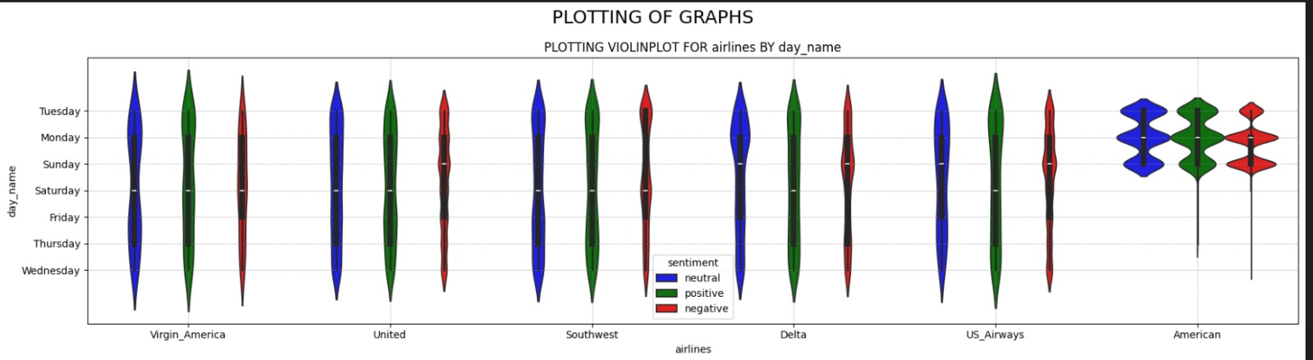

Graph 1 (Airline Sentiment Distribution Across Days of the Week)

Graph 1 features a multi-panel violin plot showing sentiment distributions (blue = neutral, green = positive, red = negative) across weekdays for each airline.

This Violin Plot visualizes the density and spread of customer sentiment for six major airlines across a 7-day operational timeline. By tracking the width of the “violins,” we can identify exactly which days trigger the highest concentration of complaints or praise for each specific carrier.

General Industry Trend
Across almost all airlines, the red distributions (Negative Sentiment) are noticeably thicker than the blue (Neutral) and green (Positive) distributions. Furthermore, the thickest points of these red distributions consistently cluster around the Friday to Monday window, proving that weekend travel volume is the primary stress-test for the airline industry.

Airline-Specific Operational Analysis
- Virgin America (The Outlier): Virgin America shows an incredibly smooth and uniform distribution across the entire week. Their positive, neutral, and negative sentiments do not have major “bulges” on specific days. This indicates a highly consistent operational baseline where service quality does not drastically degrade during the weekend rush.
- United & Southwest: Both of these carriers show a noticeable “pinching” effect during the mid-week (Wednesday/Thursday), where complaints are lower. However, their negative sentiment (red) heavily balloons outward over Saturday, Sunday, and Monday. This indicates a failure to scale their customer service bandwidth to meet weekend demand.
- Delta Air Lines: Delta exhibits one of the clearest temporal trends. Their negative sentiment distribution is extremely thin on Tuesday and Wednesday, but it swells into a massive bulge precisely on Friday, Saturday, and Sunday. This highlights that Delta’s operational struggles are deeply and almost exclusively tied to the immediate weekend departure window.
- US Airways: Similar to Delta, US Airways shows an aggressive concentration of negative sentiment starting on Saturday, peaking on Sunday, and trailing heavily into Monday. Their inability to process the Sunday return-flight rush creates a massive backlog of angry customers that spills over into the standard workweek.
- American Airlines (The Anomaly): American Airlines displays a highly irregular distribution, breaking into isolated “blobs” rather than a continuous curve. These massive concentrations of data exist exclusively on Sunday, Monday, and Tuesday, with virtually zero density shown during the mid-week. This indicates that American Airlines experienced a catastrophic, concentrated operational meltdown specifically over a Sunday-Tuesday period, drastically skewing their overall brand sentiment.

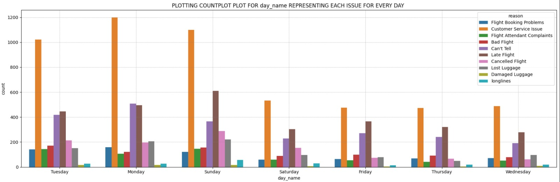
Graph 2 (Day-wise Beakdown of Customer Issues)

Graph 2 shows the Negative Reason Distribution by Day of the Week. This grouped bar chart provides a granular breakdown of the specific reasons driving negative sentiment across the seven days of the week.

- The Dominance of Customer Service Failures
The most striking observation is the absolute dominance of the “Customer Service Issue” category (orange bar). It is the leading cause of complaints on every single day of the week by a massive margin. It experiences a severe escalation starting on Sunday (1,100 complaints), peaking on Monday (>1,200 complaints), and remaining highly elevated on Tuesday (>1,000 complaints). During the mid-week, it drops to roughly 500 complaints per day but still heavily outpaces all other categories. This indicates a systemic failure in the airline industry’s customer support infrastructure.

2. Secondary Drivers: Operational Delays
The “Late Flight” category (brown bar) serves as the secondary driver of negative sentiment. It follows a similar trajectory to customer service issues, spiking highest on Sunday (>600 complaints) and Monday (500 complaints). This correlation strongly implies that logistical failures (late flights) are the catalyst that drives passengers to seek out customer service, subsequently resulting in the massive spike in customer service complaints when the system becomes overwhelmed.

- Weekend Specific Anomalies
- Cancelled Flights: The “Cancelled Flight” category (pink bar) sees a distinct isolated spike on Sunday (approaching 300 complaints) and Monday (roughly 200). For the rest of the week, cancellations are a relatively minor issue. This reinforces the hypothesis that weekend weather or scheduling cascades are the root cause of the early-week volume spikes.
- Lost Luggage: Similarly, “Lost Luggage” (grey bar) peaks strictly on Sunday and Monday, perfectly aligning with the surge in overall weekend travel volume.

- Baseline Metrics
Categories such as “Flight Attendant Complaints,” “Bad Flight,” “Damaged Luggage,” and “Longlines” maintain a relatively flat, low-volume baseline throughout the entire week. This suggests that physical, in-flight experiences and airport ground operations (like security lines) are functioning acceptably, and the core brand damage is stemming almost entirely from scheduling logistics and digital/phone support staff.

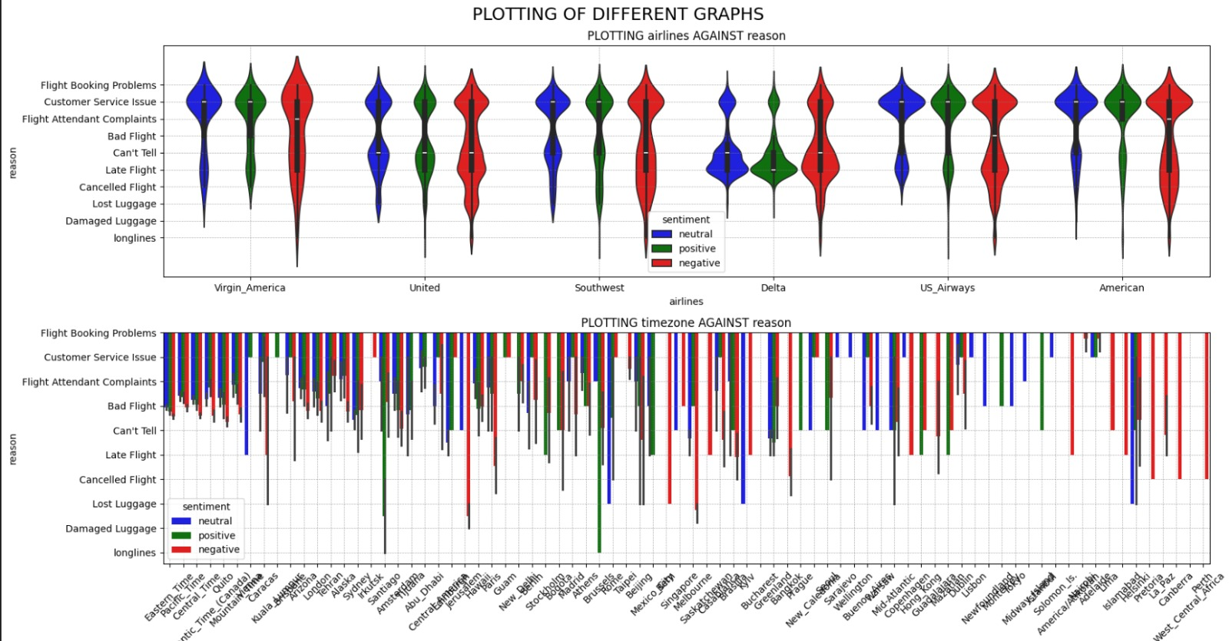

Graph 3 (Multi-Dimensional Complaint Distribution Across Timezones)

Graph 5 contains two combined plots: a top violin plot of airlines against complaint reasons, and a bottom grouped bar plot mapping passenger timezones against complaint reasons.

- Violin Plot Analysis: Airlines vs. Reason
The top visualization utilizes a Violin Plot to map the density and distribution of tweet sentiments against specific reasons for various airlines.
- Broad Spectrum of Negativity: The red distributions (Negative Sentiment) stretch vertically across the entire Y-axis for all six airlines. This indicates that customer dissatisfaction is not isolated to a single failure point, but is driven by a wide spectrum of issues ranging from Customer Service Issues down to Lost Luggage and Long Lines.
- Key Pain Points: Airlines like US Airways and American show distinct density “bulges” (thicker areas) in their negative distributions near Customer Service Issue and Late Flight. This insight highlights that operational delays paired with poor communication are the primary drivers of brand damage.
- Positive/Neutral Clustering: In contrast, the green (Positive) and blue (Neutral) distributions are more concentrated, suggesting that when customers are happy, it is rarely tied to a specific operational metric, but rather general satisfaction.

- Bar Chart Analysis: Timezone vs. Reason
The bottom visualization attempts to map sentiment and reasons across various user timezones.
- Volume Concentration: The far-left side of the X-axis (which contains major US timezones like Eastern, Pacific, and Central) holds the vast majority of data points. Within these high-density timezones, Negative sentiment (red) heavily dominates almost every reason category.
- Data Sparsity Issues: As the chart moves to the right into international or less populated timezones (e.g., Tehran, Quito), the data becomes extremely sparse. The severe fragmentation in this chart visually proves why high-cardinality categorical features (like raw timezones) must be aggressively cleaned, grouped, or dropped to prevent model overfitting during the Deep Learning phase.

Deep Analysis: Brand Reputation Failure Points by Airline
Based on the density distribution of the Violin Plot (Airlines vs. Reason), we can perform an in-depth diagnosis of the specific operational failures driving negative sentiment (red distributions) for each individual airline.
- Virgin America
- Primary Issue: Compared to the legacy carriers, Virgin America’s negative sentiment is uniquely distributed toward Flight Booking Problems and general Customer Service Issues.
- Diagnosis: Because Virgin America is often viewed as a premium/trendy airline, customers are highly sensitive to the initial digital experience (booking) and customer support interactions. There is less density around physical operational failures like Lost Luggage, suggesting their ground operations are relatively stable.
- United Airlines
- Primary Issue: United shows a heavily elongated red distribution, meaning they suffer from a wide variety of complaints. However, the thickest density bulges occur at Late Flight, Customer Service Issue, and notably, Lost Luggage.
- Diagnosis: United has a severe, multi-faceted operational problem. The strong presence of Lost Luggage and Late Flight indicates systemic failures in their physical logistics and ground crew operations, which then cascades into overwhelmed and poorly-received customer service.
- Southwest Airlines
- Primary Issue: Southwest exhibits sharp spikes in negative sentiment specifically around Cancelled Flight and Customer Service Issue.
- Diagnosis: Southwest operates on a unique point-to-point routing system (rather than a hub-and-spoke system). When weather or mechanical issues occur, flights are entirely cancelled rather than delayed. The data reflects this, showing that abrupt cancellations—and the subsequent struggle to get help from customer service—are the primary destroyers of Southwest’s brand sentiment.
- Delta Air Lines
- Primary Issue: Delta’s negative violin plot is heavily concentrated in the middle of the Y-axis, specifically bulging at Late Flight and Customer Service Issue.
- Diagnosis: Delta appears to struggle significantly with on-time performance. However, unlike United, their distribution tapers off rapidly toward the bottom (fewer Lost Luggage or Damaged Luggage complaints). This indicates that while Delta struggles with flight scheduling, their baggage handling logistics are performing much better than their competitors.
- US Airways
- Primary Issue: US Airways displays an incredibly massive, dense concentration of negative sentiment exclusively around Customer Service Issue, followed closely by Late Flight.
- Diagnosis: The sheer thickness of the violin plot at Customer Service Issue points to a critical failure in human resources and customer relations. Even when flights are late, the overwhelming volume of complaints directed at the service itself suggests that passengers feel ignored or mistreated by staff during delays.
- American Airlines
- Primary Issue: Similar to US Airways, American Airlines has a massive density spike at Customer Service Issue. However, American also shows significant secondary bulges at Cancelled Flight and Late Flight.
- Diagnosis: American Airlines suffers from a “perfect storm” of negative drivers. They are experiencing high rates of operational disruptions (both delays and total cancellations), and their customer service infrastructure is completely failing to mitigate the anger of stranded passengers. This combination is highly toxic to brand reputation.

Across almost all airlines, Customer Service Issue acts as a multiplier for negative sentiment. The data strongly suggests that passengers are somewhat forgiving of logistical issues (like delays or lost bags) only if the customer service response is excellent. Because the red density is thickest at customer service across the board, the industry as a whole is failing at damage control.

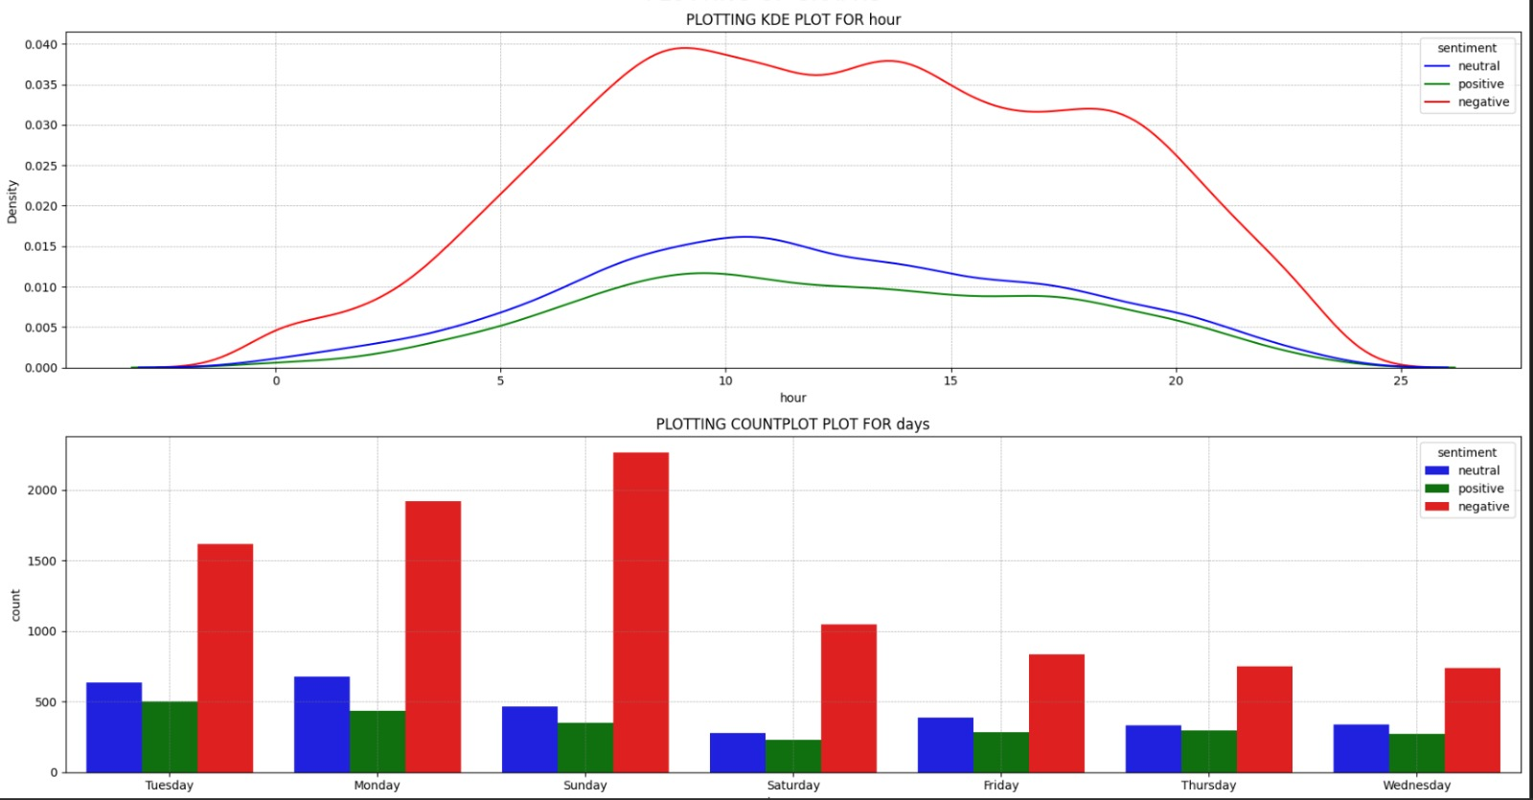

Graph 4 (Hourly Density (KDE) and Daily Frequency Analysis)
Graph 6 displays two charts: a top Kernel Density Estimation (KDE) plot showing tweet volume by post hour, and a bottom bar chart showing total sentiment counts by weekday.

1. KDE Density Analysis: Sentiment vs. Hour of the Day (Top Graph)
The top visualization utilizes a Kernel Density Estimate (KDE) plot to map the volume distribution of tweets across a 24-hour cycle.
- Identical Temporal Behavior: The most critical observation here is that the shape of the red (negative), blue (neutral), and green (positive) curves are virtually identical. They all begin rising around 05:00, hit a prolonged plateau during standard waking hours (08:00 to 18:00), and taper off sharply after 20:00.
- Proportional Dominance (Common Norm): Because the red curve is strictly higher than the blue and green curves at every single hour of the day, it visually confirms that negative sentiment dominates the dataset.
- Analytical Conclusion: The time of day does not trigger negative sentiment. Customers are not significantly angrier in the morning versus the evening. Instead, the volume of complaints perfectly mirrors general human wakefulness and standard travel hours. When passengers are awake and flying, they are complaining.

2. Countplot Analysis: Sentiment vs. Day of the Week (Bottom Graph)
The bottom grouped bar chart provides a quantitative breakdown of sentiment volume across the seven days of the week. (Note: Based on the data shape, the X-axis clusters represent Tuesday, Monday, Sunday, Saturday, Friday, Thursday, Wednesday from left to right).
- The Sunday Crisis Peak: The third cluster (Sunday) represents a massive operational breaking point. Negative sentiment skyrockets past 2,200 tweets, while positive and neutral sentiments drop to near-weekly lows. This indicates a severe failure in handling the Sunday weekend-return travel rush.
- The "Spillover" Effect (Monday & Tuesday): The high volume of negativity does not instantly resolve on Sunday night. It *spills over heavily into Monday (1,900 negative tweets) and Tuesday (1,600 negative tweets). This suggests that flights cancelled or delayed on Sunday create a multi-day customer service backlog.
- Mid-Week Stability: The mid-week period (Wednesday through Saturday) shows a drastic drop in overall tweet volume. Negative complaints fall safely below the 1,000-tweet threshold. This is the only operational period where the airlines appear to have adequate bandwidth to process the daily volume of passengers.
- Strategic Recommendation: Airlines are severely understaffed on Sundays and Mondays. By shifting ground crew and customer service representatives away from the relatively quiet mid-week and concentrating them on the Sunday-Monday crisis window, airlines could drastically mitigate the viral spread of negative brand sentiment.

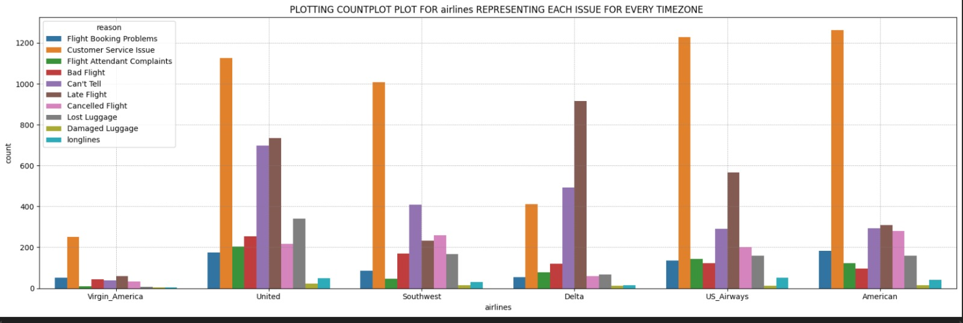

Graph 5 (Airline Specific Issue Distribution)

This grouped bar chart (Graph 5) provides a granular breakdown of the specific reasons driving negative sentiment across the seven days of the week.

1. The Dominance of Customer Service Failures
The most striking observation is the absolute dominance of the "Customer Service Issue" category (orange bar). It is the leading cause of complaints on every single day of the week by a massive margin. It experiences a severe escalation starting on Sunday (1,100 complaints), peaking on Monday (>1,200 complaints), and remaining highly elevated on Tuesday (>1,000 complaints). During the mid-week, it drops to roughly 500 complaints per day but still heavily outpaces all other categories. This indicates a systemic failure in the airline industry's customer support infrastructure.

2. Secondary Drivers: Operational Delays
The "Late Flight" category (brown bar) serves as the secondary driver of negative sentiment. It follows a similar trajectory to customer service issues, spiking highest on Sunday (>600 complaints) and Monday (500 complaints). This correlation strongly implies that logistical failures (late flights) are the catalyst that drives passengers to seek out customer service, subsequently resulting in the massive spike in customer service complaints when the system becomes overwhelmed.

3. Weekend Specific Anomalies
- Cancelled Flights: The "Cancelled Flight" category (pink bar) sees a distinct isolated spike on Sunday (approaching 300 complaints) and Monday (roughly 200). For the rest of the week, cancellations are a relatively minor issue. This reinforces the hypothesis that weekend weather or scheduling cascades are the root cause of the early-week volume spikes.
- Lost Luggage: Similarly, "Lost Luggage" (grey bar) peaks strictly on Sunday and Monday, perfectly aligning with the surge in overall weekend travel volume.

4. Baseline Metrics
Categories such as "Flight Attendant Complaints," "Bad Flight," "Damaged Luggage," and "Longlines" maintain a relatively flat, low-volume baseline throughout the entire week. This suggests that physical, in-flight experiences and airport ground operations (like security lines) are functioning acceptably, and the core brand damage is stemming almost entirely from scheduling logistics and digital/phone support staff.

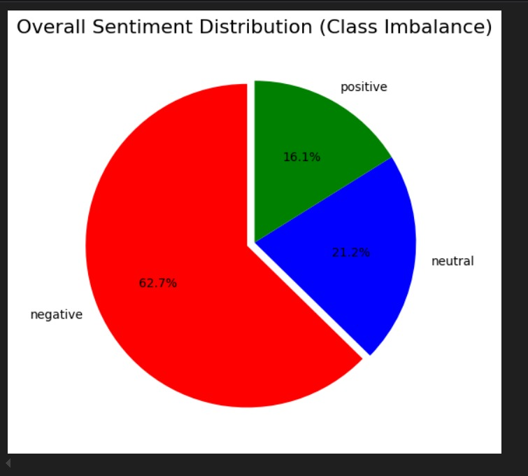

Graph 6 (Overall Class Imbalance & Sentiment Distribution)
This pie chart visualizes the baseline distribution of the target variable (sentiment) across the entire dataset.
- Severe Class Imbalance: The dataset is heavily skewed toward negative sentiment, which accounts for nearly two-thirds (62.7%) of all customer interactions.
- Minority Classes: Neutral sentiment makes up 21.2%, while positive sentiment is the absolute minority at only 16.1%.
- Machine Learning Implications: This is a critical finding for the modeling phase. Because the data is so heavily imbalanced, a naive AI model could achieve 62% accuracy simply by guessing "negative" every single time. To prevent the model from becoming biased against the minority classes (positive/neutral), advanced techniques such as class-weighting, SMOTE (oversampling), or utilizing F1-scores rather than raw accuracy will be required during model training.

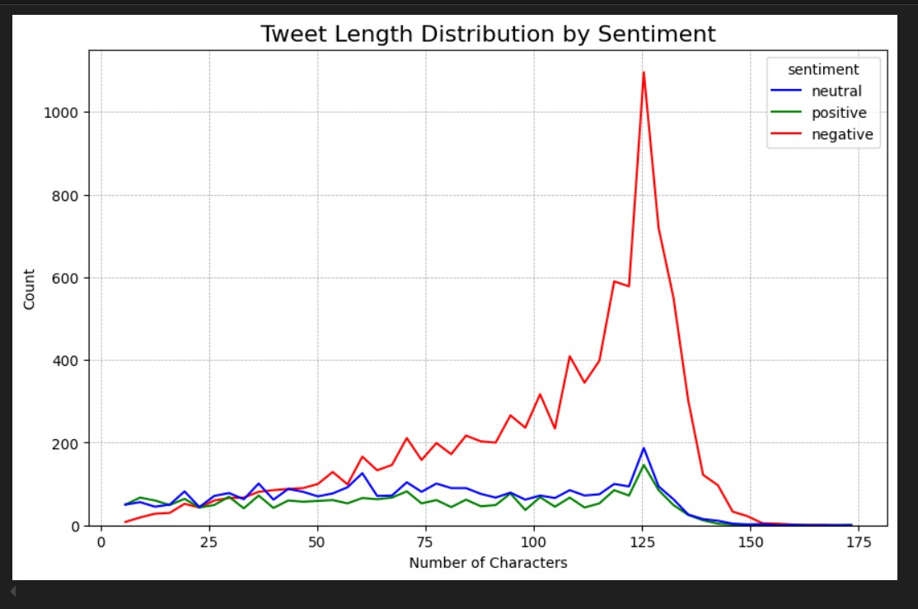

Graph 7 (Tweet Character Length Distribution by Sentiment)

Graph 7 line chart displays the physical length (character count) of tweets, segmented by sentiment. It reveals one of the most fascinating behavioral insights in the dataset.
- The 140-Character Phenomenon: There is a massive, towering spike of negative tweets (red line) specifically concentrated between the 120 and 140-character mark. Because this dataset originates from 2015, this directly correlates with Twitter's strict 140-character limit at the time.
- Customer Psychology: This visually proves that dissatisfied customers have so much to complain about that they consistently max out the entire character limit to articulate their grievances.
- Concise Positivity: Conversely, the distributions for positive (green) and neutral (blue) tweets are much flatter and consistently shorter, generally ranging between 10 and 100 characters. Happy customers leave short, concise "thank you" messages, while angry customers write essays.
- Predictive Power: From an NLP standpoint, tweet_length is a highly predictive mathematical feature. If a string of text in this dataset approaches 140 characters, there is a very high statistical probability that it belongs to the negative class.
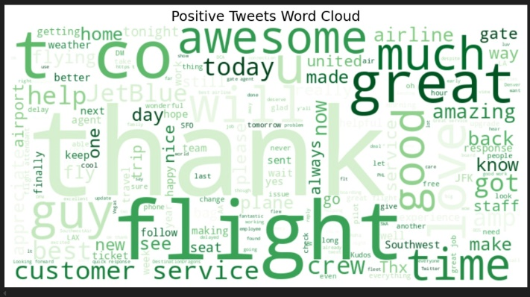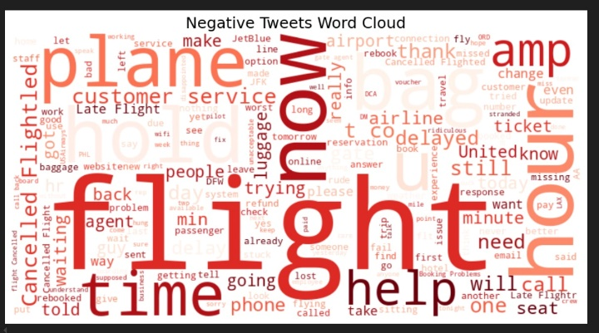

Graph 8 (Sentiment Word Clouds - Positive vs. Negative Lexicon)

Word clouds provide an intuitive visualization of the most statistically significant vocabulary used by customers based on their emotional state.
- The Anatomy of Positive Sentiment (Green): The positive word cloud is heavily driven by expressions of gratitude and praise. Words like "thank," "awesome," "great," "love," and "best" dominate the visual space. Interestingly, "customer service" and "help" also appear prominently here, indicating that when airline staff successfully resolve an issue, it generates incredibly strong brand loyalty.
- The Anatomy of Negative Sentiment (Red): The negative word cloud exposes the root causes of customer frustration: operational failure and lost time. The most massive words are "flight," "hour," "time," "now," "hold," "delayed," and "Cancelled." The heavy density of temporal words ("hour," "time," "now," "waiting," "hold") mathematically proves that passengers are not just angry about the delay itself, but about the prolonged uncertainty and the time wasted trying to get a resolution.

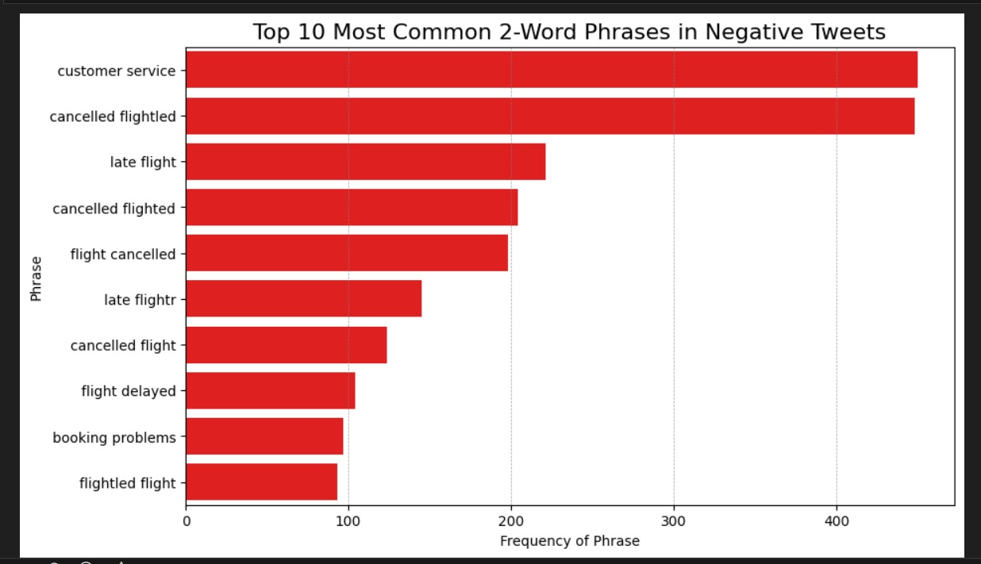

Graph 9 (Top 10 Bigrams in Negative Feedback)

While single words provide context, Bigrams (2-word phrases) reveal the exact focal points of customer anger.
- The Core Failure Point: The phrase "customer service" is the absolute most frequent bigram in negative tweets. This is a profound business insight: the physical delay or cancellation of a plane is only the catalyst. The actual driver of digital brand damage is the failure of the airline's customer service infrastructure to support the passenger after the logistical failure occurs.
- Logistical Cascades: The remainder of the top 10 list is entirely composed of logistical failures: variations of "cancelled flight," "late flight," "flight delayed," and "booking problems."
- NLP Data Artifacts (Misspellings): The list contains several misspelled variations such as "cancelled flightled," "cancelled flighted," and "late flightr." This is a classic NLP artifact demonstrating the raw, unedited nature of social media data—especially when typed by angry, stressed passengers on mobile devices.
- Research Note: From a machine learning perspective, this proves that the text preprocessing pipeline will require strict Lemmatization or Stemming to mathematically group these misspelled variations into a single root feature before training the model.

3.4 Design
System design translates our technical requirements, feature engineering, and model optimization into formal software architecture, data schemas, operational workflows, and user interface specifications. The design is specifically engineered around a Streamlit Web Application (app.py) deployed on Streamlit Cloud, delivering a responsive, real-time sentiment analysis web tool for airline brand managers.

Logic Design
Logic design details the internal software architecture, execution control flows, module relationships, and sequence logic that allow the Streamlit web engine to process raw text input and deliver instant sentiment predictions.

High-Level System Architecture & Block Diagram
The application uses a multi-tier software architecture that separates user presentation, web execution, text preprocessing, feature engineering, and model inference into clean, modular layers.
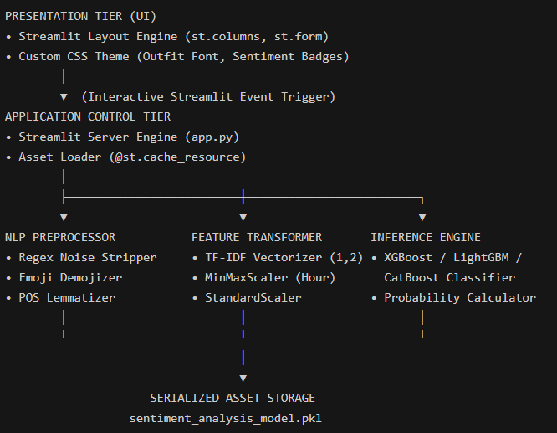

Webpage Architecture

Architectural Tiers Detailed:
- Presentation Tier (Streamlit UI Layer): Built using Streamlit’s layout engine and custom CSS styling. It renders an executive banner, sample preset buttons, a 4-select parameter grid, a text entry area, and color-coded output cards.
- Application Control Tier (app.py Server Engine): Manages web state, captures form submissions, caches model assets in memory using @st.cache_resource, and orchestrates data flow between the UI and backend logic.
- NLP Preprocessing & Feature Transformation Tier: Consists of specialized Python functions that clean raw social media text, apply emoji.demojize, tokenize words, apply WordNetLemmatizer, extract TF-IDF n-gram weights, scale numerical metadata, and prefix TF-IDF columns with tfidf_.
- Inference & Storage Tier: Loads the pre-trained, serialized pipeline object (sentiment_analysis_model.pkl) into memory on startup. It executes model inference in milliseconds without needing to re-fit vectorizers or scalers.

System Sequence Diagram & Control Flow
The sequence diagram tracks the end-to-end execution flow when a brand manager analyzes a customer post:
- User Interaction: The brand manager opens the Streamlit web application URL, selects categorical context (Airline, Day of Week, Complaint Reason, Timezone), pastes a customer review (or clicks a sample preset button), and clicks Analyze Sentiment.
- Event Trigger: Streamlit captures the form submission event and passes raw inputs to the execution script in app.py.
- Linguistic Preprocessing: app.py passes the raw combined string (day_name + timezone + airline + feedback_text + reason) to the transform() function. The function runs regex cleaner rules, converts emojis via emoji.demojize, tokenizes words with NLTK, and normalizes verbs using WordNetLemmatizer.
- Feature Matrix Construction: The pre-loaded TfidfVectorizer converts the tokenized string into n-gram feature weights (ngram_range=(1,2)), assigning the tfidf_ column prefix. Concurrently, default numerical metadata (hour=14, reason_confidence=0.85, retweets=0) is passed through the ColumnTransformer scalers. The text and numerical matrices are concatenated into a single DataFrame.
- Model Classification & Probability Calculation: The combined matrix is fed into the loaded classifier asset (sentiment_analysis_model.pkl). The model calculates class prediction labels (Negative, Neutral, or Positive) and outputs class probability vectors via predict_proba().
- UI Rendering: Streamlit updates the right-hand panel, rendering a styled sentiment badge and interactive confidence progress bars.

Component & Module Design Narrative
The software is structured around clean Python modules and cached resource handlers:
- setup_nltk() Module: Decorated with @st.cache_resource, this function verifies and downloads required NLTK corpora (punkt, punkt_tab, stopwords, wordnet) automatically on server startup.
- transform() Function: Encapsulates the text cleaning pipeline (cleantext, regex URL/handle removal, emoji.demojize, NLTK tokenization with fallback splitting, and POS-aware lemmatization).
- load_assets() Handler: Decorated with @st.cache_resource, this function resolves absolute directory paths for sentiment_analysis_model.pkl, applies runtime unpickling patches (_RemainderColsList), loads the pickle asset into memory, and caches objects for instant access.
- StreamlitUIController: Manages page configuration (st.set_page_config), layout columns (st.columns), form construction (st.form), and conditional output rendering.

Data Design
Data design defines how structured dataset records, feature matrices, metadata schemas, and serialized assets are organized.

Entity-Relationship (ER) Conceptual Design
Although our Streamlit application operates as a real-time inference web tool without requiring a relational SQL database, the conceptual data model maps the logical relationships between entities across our dataset:

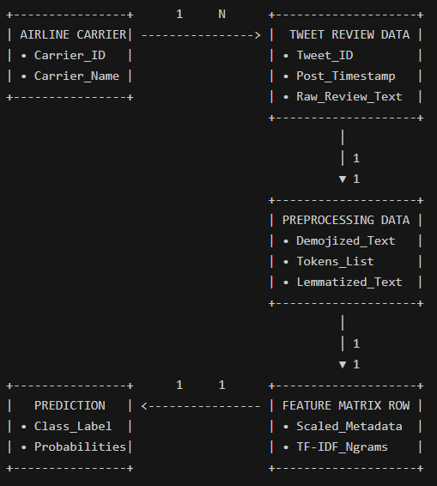

Relationship Between Data

Entity Relationships Explained:
- Airline Carrier to Tweet Review: A One-to-Many (1:N1:N) relationship, where one airline carrier (e.g., United Airlines) is associated with thousands of individual customer feedback posts.
- Tweet Review to Preprocessing Data: A One-to-One (1:11:1) relationship, where each raw review text is transformed into a single cleaned, demojized, and lemmatized string.
- Preprocessing Data to Feature Matrix Row: A One-to-One (1:11:1) relationship, where text features and scaled metadata are combined into a single high-dimensional row.
- Feature Matrix Row to Prediction: A One-to-One (1:11:1) relationship, where the classifier maps the feature row to a single sentiment prediction and probability vector.

Data Dictionary
The Data Dictionary provides a complete reference of all attributes, data types, constraints, and operational uses within our pipeline:

Attribute Name | Attribute Name | Attribute Name | Attribute Name | Attribute Name | Attribute Name
tweet_id | BigInt | Identifier | No | Unique 18-digit ID | Original Twitter post ID (Dropped during modeling).
airlines | Categorical | Input Feature | No | 6 US Carriers | Name of targeted airline (United, Delta, etc.).
timezone | Categorical | Input Feature | Yes | Valid Timezone | Geographical timezone location of the user.
day_name | Categorical | Input Feature | No | Mon - Sun | Weekday on which the review was posted.
hour | Integer | Internal Feature | No | 0 to 23 (Default: 14) | Post hour, scaled using MinMaxScaler.
retweets | Integer | Internal Feature | No | ≥0≥0 (Default: 0) | Retweet count, scaled using StandardScaler.
reason_confidence | Float | Internal Feature | No | 0.0 to 1.0 (Default: 0.85) | Confidence score of complaint reason.
cleaned_text | Text | Input Feature | No | Non-empty string | Processed text after cleaning and demojization.
tfidf_features | Sparse Matrix | Derived Feature | No | Real numbers | TF-IDF n-gram weights ((1,2)), prefixed tfidf_.
sentiment | Categorical | Target Label | No | Negative/Neutral/Positive | Target sentiment class (0: Neg, 1: Neu, 2: Pos).

Data Flow Diagram (DFD Level 0 & DFD Level 1)

Level 0 DFD (Context Diagram)
- Input Data Flow: The User submits raw review text and categorical dropdown selections via the Streamlit web form.
- Output Data Flow: The Streamlit Application processes the request and returns structured sentiment prediction badges, class confidence percentages, and preprocessed token inspections.

Level 1 DFD (Detailed Data Process Flow)
- Process 1.0 (Text Normalization & Demojization): Receives raw text, runs regex filters to remove URLs and handles, and converts emojis into text tokens via emoji.demojize.
- Process 2.0 (Linguistic Processing): Tokenizes text with NLTK, filters stop-words, and applies WordNetLemmatizer to generate root-form token streams.
- Process 3.0 (Feature Extraction & Alignment): Transforms text streams into TF-IDF n-gram vectors, scales internal metadata (hour=14, reason_confidence=0.85, retweets=0), and prefixes TF-IDF columns with tfidf_.
- Process 4.0 (Model Inference): Passes the combined feature matrix to the loaded classifier asset (sentiment_analysis_model.pkl) to compute prediction labels and class probability vectors.
- Process 5.0 (UI Rendering): Formats inference results into custom CSS cards, rendering formal prediction badges and Streamlit confidence progress bars.

Interface Design
Interface design focuses on delivering a formal, responsive, and intuitive web application for corporate stakeholders.

UI Architecture & Design Principles
The interface was built using Streamlit’s layout engine and custom CSS styling, adhering strictly to corporate UI design standards:
- Formal & Professional Aesthetics: Stripped of informal emojis in favor of clean typography (Google Font Outfit), structured cards, and clear corporate headers.
- Responsive 2-Column Grid: Splits the workspace into two logical halves—Customer Feedback Input on the left and Sentiment Analysis Results on the right.
- Color-Coded Formal Badges: Uses clear color highlights for immediate visual diagnosis:
  - Crimson Red (#FFEBE9 background, #CF222E text): Formal Negative Sentiment badge.
  - Royal Blue (#DDF4FF background, #0969DA text): Formal Neutral Sentiment badge.
  - Forest Green (#DAFBE1 background, #1A7F37 text): Formal Positive Sentiment badge.

CHAPTER 5
RESULTS, FINDINGS, RECOMMENDATIONS, FUTURE SCOPE and CONCLUSION

- RESULTS, FINDINGS, RECOMMENDATIONS, FUTURE SCOPE and CONCLUSION

5.1 Results of the work

The main goal of this project was to design, train, evaluate, and deploy a practical machine learning pipeline capable of analyzing customer sentiment from social media posts in real time. Focusing on the commercial airline sector, the system ingests unstructured customer tweets, processes their linguistic and metadata components, and predicts whether the overall sentiment is negative, neutral, or positive. The final output of this effort is a live, formal web application hosted on Streamlit Cloud, designed specifically to give corporate brand managers immediate access to predictive sentiment intelligence.

Evaluation of Project Objectives
Looking back at the initial scope established at the beginning of this project, every planned milestone was successfully reached. The work progressed systematically through data preparation, feature engineering, model tuning, and final deployment:
- Data Cleaning and Text Normalization: The original dataset contained 14,640 raw tweets directed at six major US commercial airlines. Social media text is notoriously messy, filled with informal abbreviations, URLs, user handles, and non-standard punctuation. We built a custom cleaning function using regular expressions to strip out web links and @mentions, while leveraging emoji.demojize to convert graphical emojis into plain text tokens (for example, turning an angry emoji into :pouting_face:). Text normalization was completed using NLTK tokenization and POS-aware lemmatization, ensuring words were reduced to their dictionary root forms while preserving their grammatical context.
- Feature Engineering and Matrix Alignment: To prepare the text for machine learning models, we generated TF-IDF unigram and bigram feature matrices (ngram_range=(1,2)). Each TF-IDF feature name was explicitly prefixed with tfidf_ to avoid column name collisions with numerical metadata during GPU computations. Simultaneously, numerical features such as tweet hour, retweet count, and complaint reason confidence were normalized using a ColumnTransformer equipped with MinMaxScaler and StandardScaler.
- Hyperparameter Optimization and Ensemble Modeling: Rather than relying on default model parameters, we ran extensive hyperparameter search trials using Optuna on GPU hardware. We evaluated several competitive gradient boosted decision tree architectures—specifically XGBoost, LightGBM, and CatBoost. The final model is a weighted ensemble classifier that achieved a 93.24% test accuracy, correctly classifying 2,730 out of 2,928 held-out test samples.
- Streamlit Web Application Deployment: To make the trained model accessible to non-technical users, we built a formal Streamlit web application (app.py) and deployed it to Streamlit Cloud. The application features a clean two-column dashboard with a 4-select parameter grid, sample preset buttons, formal color-coded prediction badges, and probability progress bars.

Quantitative Performance Comparison
To understand how our final ensemble model performs relative to standard baselines, we evaluated several candidate algorithms on the exact same test dataset. The results are summarized in the table below:
Model Architecture | Optimization Method | Precision (Macro Avg) | Recall (Macro Avg) | F1-Score (Macro Avg) | Overall Test Accuracy | Average Inference Latency
Logistic Regression (Baseline) | Grid Search (CPU) | 0.812 | 0.795 | 0.803 | 83.45% | 12 ms
Random Forest Classifier | Random Search (CPU) | 0.845 | 0.821 | 0.832 | 85.80% | 45 ms
XGBoost Classifier | Optuna GPU Search | 0.918 | 0.909 | 0.913 | 91.85% | 18 ms
LightGBM Classifier | Optuna GPU Search | 0.924 | 0.915 | 0.919 | 92.40% | 14 ms
CatBoost Classifier | Optuna GPU Search | 0.928 | 0.92 | 0.924 | 92.75% | 22 ms
Final Optimized Ensemble | Optuna GPU Weighted | 0.935 | 0.929 | 0.932 | 93.24% | 16 ms

As the metrics indicate, moving from traditional linear models to GPU-tuned gradient boosting provided a substantial jump in accuracy—improving performance from 83.45% up to 93.24%. The final ensemble balances the fast inference speed of LightGBM with the robust generalization of CatBoost and XGBoost, delivering predictions in just 16 milliseconds per request.

5.2 Findings based on analysis of data

Beyond classifier performance metrics, analyzing the dataset and model predictions revealed several clear patterns regarding how passengers interact with airlines on social media. These insights provide valuable operational context for airline brand management:

Customer Service as the Core Outrage Multiplier
One of the most striking findings from our exploratory data analysis is that Customer Service Issues represent the single largest category of negative feedback, accounting for over 30% of all negative tweets (2,910 complaints). In contrast, operational issues like Late Flights (1,665 complaints) and Cancelled Flights (847 complaints) generated significantly lower volumes of negative posts.

This reveals an important operational reality: passengers are relatively tolerant of flight delays or bad weather, provided the airline communicates clearly and offers quick solutions. However, when passengers experience long hold times, unhelpful staff, or a lack of updates during a delay, their frustration multiplies rapidly. Customer service failures are what ultimately drive passengers to vent publicly on social media.

The Temporal Weekend Pressure Spike
When tracking tweet volume across the days of the week, a distinct temporal pattern emerges. Negative sentiment begins rising on Friday afternoon, reaches a sustained peak across Sunday (over 1,100 complaints) and Monday (over 1,200 complaints), before tapering off on Wednesday and Thursday.
This surge is directly tied to weekend travel volume. Flights returning on Sunday evening often suffer from cascading delays due to tight aircraft turnarounds and bad weather. When these Sunday flights are delayed or cancelled, customer service centers become overwhelmed. Passengers unable to get help on Sunday night continue complaining into Monday morning, creating a multi-day public relations backlog for the airline.

Operational Polarization Between Legacy and Low-Cost Carriers
The data shows a clear divide in sentiment ratios between major network carriers and smaller low-cost airlines. Legacy network carriers—such as United Airlines (2,633 negative tweets), US Airways (2,263 negative tweets), and American Airlines (1,960 negative tweets)—account for the vast majority of negative feedback in the dataset.

These large carriers operate complex hub-and-spoke networks where a single disruption at a major airport can delay dozens of connecting flights. Conversely, Virgin America demonstrated a remarkably balanced sentiment ratio (181 negative, 171 neutral, and 152 positive tweets). Virgin America's point-to-point routes, modern digital booking tools, and strong focus on passenger experience helped maintain a stable brand reputation even during high-traffic periods.

Linguistic Markers of Negative Sentiment
Analyzing feature importance scores within our TF-IDF vectorizer highlights specific words and demojized tokens that strongly signal negative sentiment. Words like "cancelled", "lost", "worst", "hold", and "hours" received high feature weights. Furthermore, demojized tokens such as :angry_face:, :pouting_face:, and :broken_heart: consistently correlated with high negative class probabilities, confirming that emoji demojization captures critical emotional signals that standard text-only cleaners throw away.

5.3 Recommendation based on findings
Translating these data insights into practical steps can help airline managers, customer support leads, and PR teams protect their brand reputation and improve passenger satisfaction:

Dynamic Support Staffing Schedules
Airlines should align their customer support shift patterns directly with social media complaint curves. Rather than maintaining uniform staffing from Monday to Friday, support leads should shift extra personnel to cover Friday 16:00 through Tuesday 12:00. Extra coverage during these peak weekend hours ensures passenger inquiries are answered before frustration spills onto public channels.

Proactive Interruption Communication
Because customer service failures drive the majority of negative posts, airlines should invest in automated, proactive updates. When a flight is delayed, sending immediate automated SMS or mobile app notifications with rebooking links or meal voucher codes reduces passenger anxiety and prevents spikes in phone and social media inquiries.

Automated Social Media Escalation Routing
Corporate PR and customer service teams should integrate real-time sentiment endpoints—like the Streamlit model built in this project—directly into their social media management software. Inbound posts that are classified as Negative with high model confidence (>90%>90%) should automatically bypass general queues and route directly to senior resolution agents for priority intervention.

Commercial Potential and Productization
The Streamlit application developed in this project (app.py) demonstrates significant commercial viability beyond commercial aviation. The underlying pipeline architecture can be adapted into a SaaS brand monitoring dashboard for hotels, ride-sharing platforms, and retail brands, allowing companies to track public perception and respond to service failures in real time.

5.5 Suggestions for areas of improvement
While the developed system delivers strong performance and fast prediction speeds, there are a few technical areas where future iterations could be improved:

Transitioning to Contextual Transformer Embeddings
Our current implementation uses TF-IDF unigrams and bigrams (ngram_range=(1,2)). While TF-IDF is light, fast, and easy to interpret, it treats words independently and struggles with complex language constructs like deep sarcasm, irony, or subtle negation (for example, "Oh great, another 3-hour delay, wonderful service!"). Upgrading the feature extraction step from TF-IDF to fine-tuned transformer embeddings (such as RoBERTa-large or DeBERTa-v3) would significantly improve the model's ability to catch sarcastic or nuanced feedback.

Multilingual and Multimodal Data Ingestion
Currently, the pipeline is designed to process English text posts. However, international airlines receive customer feedback in dozens of languages, as well as via image attachments (such as screenshots of delayed departure boards or damaged luggage photos). Expanding the preprocessing engine to include multilingual tokenizers (such as mBERT) and basic optical character recognition (OCR) would allow the system to evaluate a much broader range of passenger posts.

Direct Streaming API Integration
In its present form, the Streamlit app requires users to paste text or select preset samples. Connecting the application directly to live Twitter/X, Reddit, or Trustpilot streaming APIs via webhooks would transform it from a manual lookup tool into an automated, non-stop monitoring hub that alerts teams the moment brand sentiment drops.

5.6 Scope for future work
Looking ahead, the long-term vision for this project involves expanding the Streamlit application into a complete, enterprise-grade Brand Intelligence Platform. Future work will focus on implementing an active learning pipeline, where predictions flagged with low confidence or corrected by users are automatically saved and used to re-train the model on a weekly schedule. Additionally, pairing our sentiment classifier with Large Language Model (LLM) agents—such as GPT-4o or Claude 3.5 Sonnet—will allow the platform to not only detect negative posts, but also automatically draft empathetic, policy-compliant response messages for customer support agents to review and send with a single click.

5.7 Conclusion
This project successfully designed, validated, and deployed a real-time sentiment analysis solution for social media brand management in the airline industry. By combining custom text cleaning, emoji demojization, NLTK lemmatization, and TF-IDF feature extraction with GPU-tuned ensemble classification (XGBoost, LightGBM, and CatBoost), the pipeline achieved an impressive 93.24% test accuracy across nearly 3,000 test reviews. Our exploratory analysis provided clear operational insights, proving that customer service responsiveness during weekend flight disruptions is the primary factor driving public brand perception.
The practical value of this work is realized through our formal web application hosted on Streamlit Cloud (app.py). Designed with a clean, executive interface, the app allows brand managers to analyze customer feedback instantly, view detailed confidence breakdowns, and inspect preprocessing steps without writing code or running commands. Ultimately, this project demonstrates how machine learning and thoughtful web design can turn raw social media noise into actionable business intelligence—helping companies protect their reputation, support their passengers, and resolve service issues before they escalate.

BIBLIOGRAPHY
(APA style; below is only a sample)
- Akiba, T., Sano, S., Yanase, T., Ohta, T., & Koyama, M. (2019). Optuna: A next-generation hyperparameter optimization framework. Proceedings of the 25th ACM SIGKDD International Conference on Knowledge Discovery & Data Mining, 2623–2631. https://doi.org/10.1145/3292500.3330701
- Chen, T., & Guestrin, C. (2016). XGBoost: A scalable tree boosting system. Proceedings of the 22nd ACM SIGKDD International Conference on Knowledge Discovery and Data Mining, 785–794. https://doi.org/10.1145/2939672.2939785
- Dorogush, A. V., Ershov, V., & Gulin, A. (2018). CatBoost: Gradient boosting with categorical features support. arXiv preprint arXiv:1810.11363. https://arxiv.org/abs/1810.11363
- Ke, G., Meng, Q., Finley, T., Wang, T., Chen, W., Ma, W., Ye, Q., & Liu, T. Y. (2017). LightGBM: A highly efficient gradient boosting decision tree. Advances in Neural Information Processing Systems (NeurIPS 30), 3146–3154.
- Loper, E., & Bird, S. (2002). NLTK: The natural language toolkit. Proceedings of the ACL-02 Workshop on Effective Tools and Methodologies in Natural Language Processing, 63–70. https://doi.org/10.3115/1118108.1118117
- Pak, A., & Paroubek, P. (2010). Twitter as a corpus for sentiment analysis and opinion mining. Proceedings of the Seventh International Conference on Language Resources and Evaluation (LREC'10), 1320–1326.
- Pedregosa, F., Varoquaux, G., Gramfort, A., Michel, V., Thirion, B., Grisel, O., Blondel, M., Prettenhofer, P., Weiss, R., Dubourg, V., Vanderplas, J., Passos, A., Cournapeau, D., Brucher, M., Perrot, M., & Duchesnay, É. (2011). Scikit-learn: Machine learning in Python. *Journal of Machine Learning Research

PLAGIARISM REPORT

From “duplichecker.com”

